Dyslexia and Inclusive Practice: From Understanding to Action: Reflective log
Name:
Role:
Place of work:
Sector:
Line manager:
Local authority/ independent establishment:

Dyslexia and Inclusive Practice: From Understanding to Action: Reflective log
This reflective log supports your reflective learning journey. You may want to revisit the log regularly, or use it as evidence of your professional development, reflective practice and critical self-evaluation. If you are a GTCS registered teacher this can contribute towards your GTCS professional update. Make sure that you save this reflective log after you start to fill it so that it’s easy to find. The next time you are prompted to add to the log, you should open the file you saved and add the new material to it. How you choose to complete the log is your personal preference, you can adapt this log and present your reflections of the question in alternative ways to suit your needs.
Choose which GTCS Self-evaluation wheel you will focus on throughout this programme.
Document > Self-evaluation wheel: Standard for Full Registration
Document > The Standard for Career-Long Professional Learning
Both self-evaluations should support you to:
- Reflect on what you have done
- Think about what you might do next
- Consider your own progress and development
- Deeply understand your professional practice, your professional learning and the impact of this on your thinking, professional actions, those you work with/support and the pupils and their learning
- to critically reflect on yourself as a professional and your practice
- Perform a simple gap analysis - for example where are you now and where would you like to be

1.3 Reflective activity 1
Note your responses

- What do you, as an educator, hope to gain from this resource and activity?

- Write down two specific goals that apply to your unique situation.

Part Two. Understanding the Scottish Context Reflection points
The Scottish legislative and policy framework

2.4 Reflective Activity 2
Note your responses.

- Apply the 5 questions from the GIRFEC practice model to your own unique context and the child or young person you are supporting. Ask yourself the 5 questions. Your answers will help guide the support your child/young person may need.

- What is getting in the way of this child or young person’s wellbeing?

- Do I have all the information I need to help this child or young person?

- What can I do now that is needed and appropriate to help this child or young person?

- What can my agency or organisation do now to help this child or young person?

- What additional help, if any, may be needed from others?

- Plot the 8 wellbeing indicators on the self-evaluation wheel as they apply to your child/young person in your particular context.

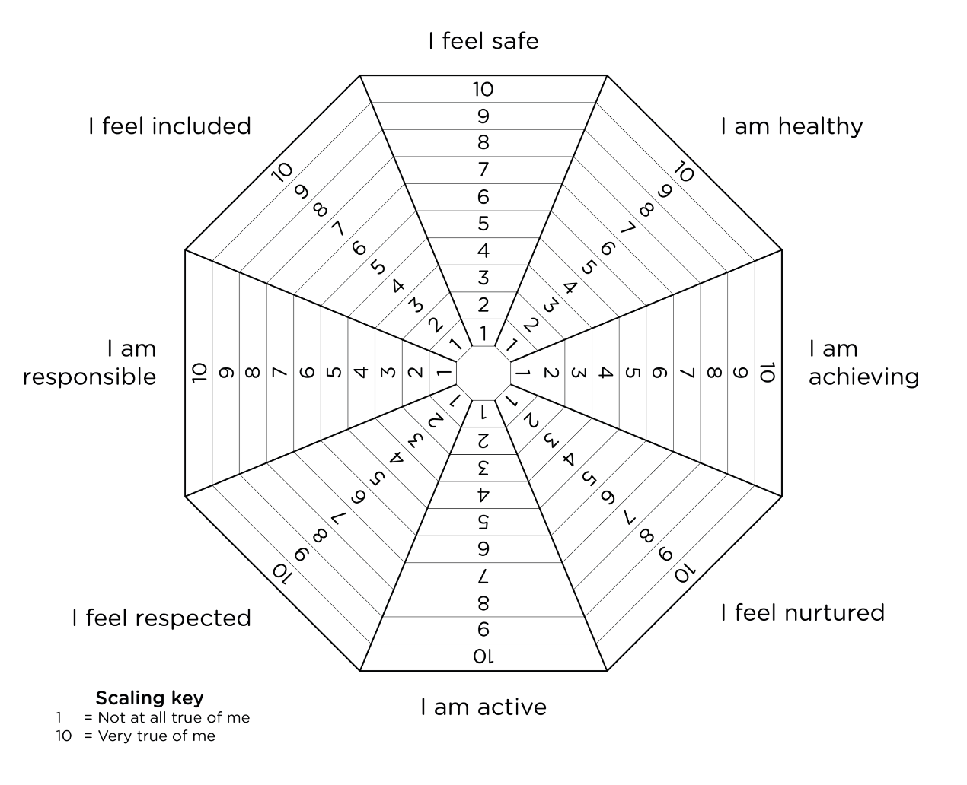
Aberdeenshire Wellbeing Web. Child-Young-Persons-Wellbeing-Web-2025
Child-Young Person’s Wellbeing Web 2020

Using the wheel:·
Consider each point on the wheel in turn.
Think about the wellbeing indicators and where you might place your child/young person on the wheel:
0 indicates not confident/lots of areas to develop or work on;
10 indicates very confident/accomplished in this area.
Think about ‘why’ you place your child / young person on that point.
Looking at areas you have identified, what should/could be your next steps to help take support forward?

- What do you notice about the completed wheel?

- Which areas stand out as strengths?

- Which areas need support?

2.7 Reflective Activity 3 - Working Definition Matching Activity

Draw a line connecting the criteria for Scotland’s working definition of dyslexia in the left column to the everyday interpretation of these criteria in the right-hand column.

A continuum of difficulties in learning to read, write and/or spell. |  | Having dyslexia means someone can be very competent in some areas of the curriculum but still struggle with reading and writing.
Persist despite the provision of appropriate learning opportunities. |  | A person might be really good at art or mathematics but find reading a simple menu very difficult.
Do not reflect an individual’s cognitive abilities |  | Ranges from mild to severe, and every person's experience is different.
May not be typical of performance in other areas. |  | If the environment is supportive, the impact of dyslexia is low. The opposite is true if the environment is not supportive.
Impact as a barrier to learning varies in degree according to the learning, teaching and working environment. |  | Even with good intervention the difficulties with reading and writing do not simply go away.

3.2 Reflective Activity 4

Consider the words and phrases below that might reflect a young person’s loss of self-confidence as a result of literacy difficulties.
Note your responses.

insecure hesitant capable fearful bold clowning around
anxious afraid assertive optimistic apologetic needy
decisive unsure self-assured avoidant hardworking proactive

- Consider other words you may have thought of.

- Do you recognise any of these behaviours in your child/young person?


3.4. Reflective Activity 5
‘Dyslexia is an advantage.’
Discuss this statement drawing on your own classroom experience and on what you have read/considered in this module.
It may help to record this in the table below.

Pros | Cons

3.5 Reflective Activity 6
Note your responses.

- What activities require a level of literacy in the everyday lives of your pupils?

- If this is a challenge for children and young people, consider how the difficulties could be reduced?
For example – reading a recipe in home economics

3.6 Reflective Activity 7
Use your Reflective log to note your responses.

- Watch the films of some famous people speaking about their dyslexia.
Famous people with dyslexia | Dyslexia Scotland - Dyslexia Scotland

- Choose one famous person’s story that stands out for you in some way.

- Why does it stand out for you?

- Explain if and how their story has increased your understanding of dyslexia in any way?

4.5 Reflective Activity 7
Note your responses.

As an educator, consider the point below:
- The personal interests a dyslexic child/young person in your classroom has
- Their personal learning preferences at school
- The strengths they show.
Fill these in on the table below

Personal interests | Personal learning preferences | Personal strengths

Additional Notes

