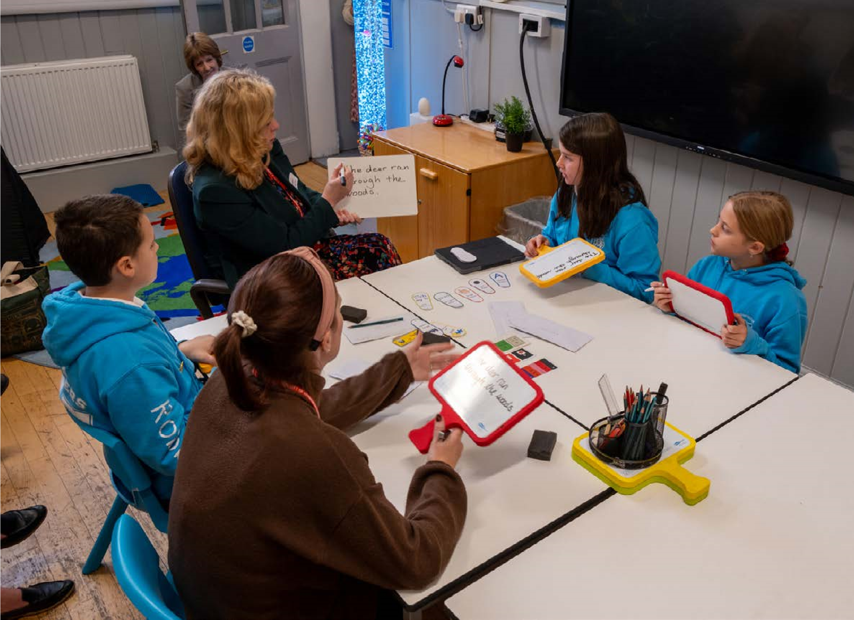

DLA Printable Teaching Strategies and Practical Resources.

Assessment, Support and Planning for Literacy Difficulties and Dyslexia PLA:

Sean Connery Foundation Legacy: Learning from the Dyslexia Initiative.

Contents Page

Syllable Count Game 2 – 6

Teaching Common Word Reading: 5 Part Strategy Helpsheet 7 - 10

Precision Teaching - Reading (Common words) 11 -12
Simultaneous Oral Spelling (SOS) 13
Common Word Spelling-‘Nailed it’ Method, incorporating Simultaneous Oral Spelling 14
Precision Teaching – Spelling (Common words) 15 -17
Assisted and Independent Blending (for Reading) 18 -20
Make and Break Spelling Help Sheet 21
Dictation Help Sheet. 22
Five Finger Test 23
Three Read Strategy Help Sheet. 24
Repeated Reading 25
Flash Card Games with Minimal Preparation 26
Noughts and Crosses (cvc) 27 - 29
Noughts and Crosses Game template (x6) 30- 33
Four in a Row. (‘th’ words) 34
Four in a Row. (‘th’ words) Instructions. 35
Sharing Learning: Home School Link templates 36

Syllable Count Game (Print Pages 2 – 6)
Equipment
- 1 set of picture cards
- 1 ladder for each child
- 1 counter for each child

Instructions
- Print, laminate and cut out picture cards.
- Copy one ladder for each child
- Shuffle cards well, put in a pile in the centre
- Children take it in turns to take top card, say the word and decide how many syllables (Help by exaggerating syllables or clapping out with child)
- If correct number of syllables, then child moves counter the same number of rungs up the ladder
- First to the top wins
- Begin just using 1 and 2 syllable picture cards, then gradually introduce 3 syllables, then 4.

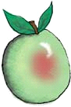 | 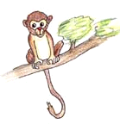 | 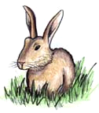 | 
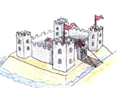 |  |  | 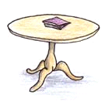
 |  | 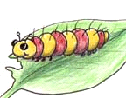 | 
 |  |  | 

 |  |  | 
 |  |  | 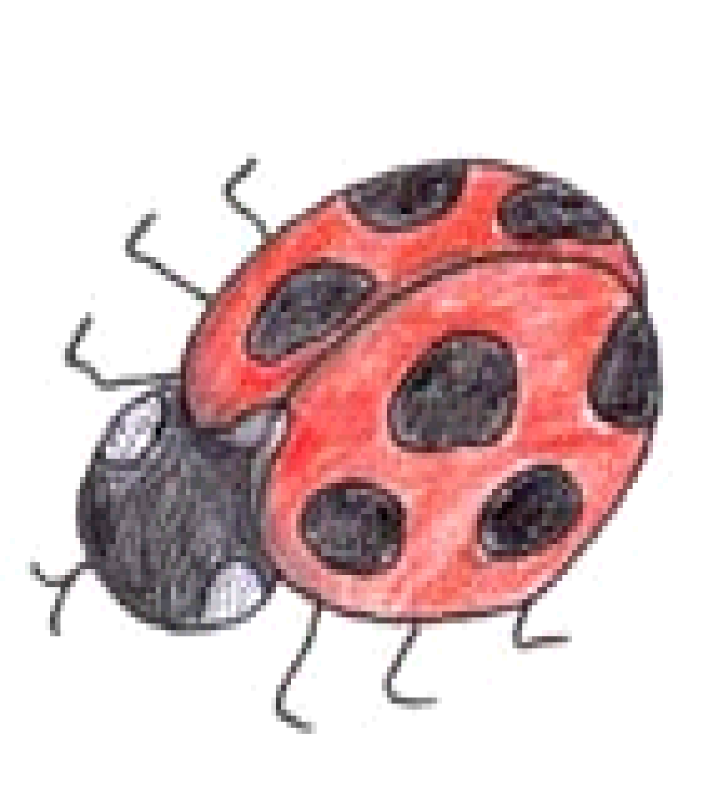
 | 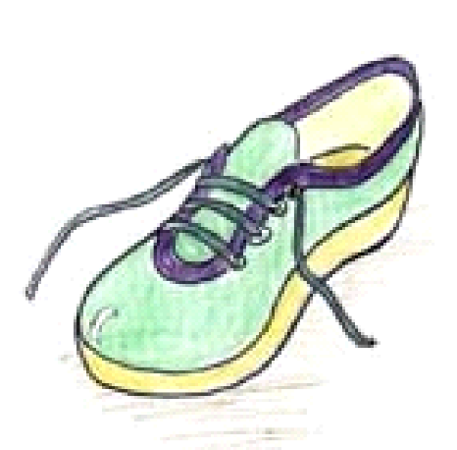 | 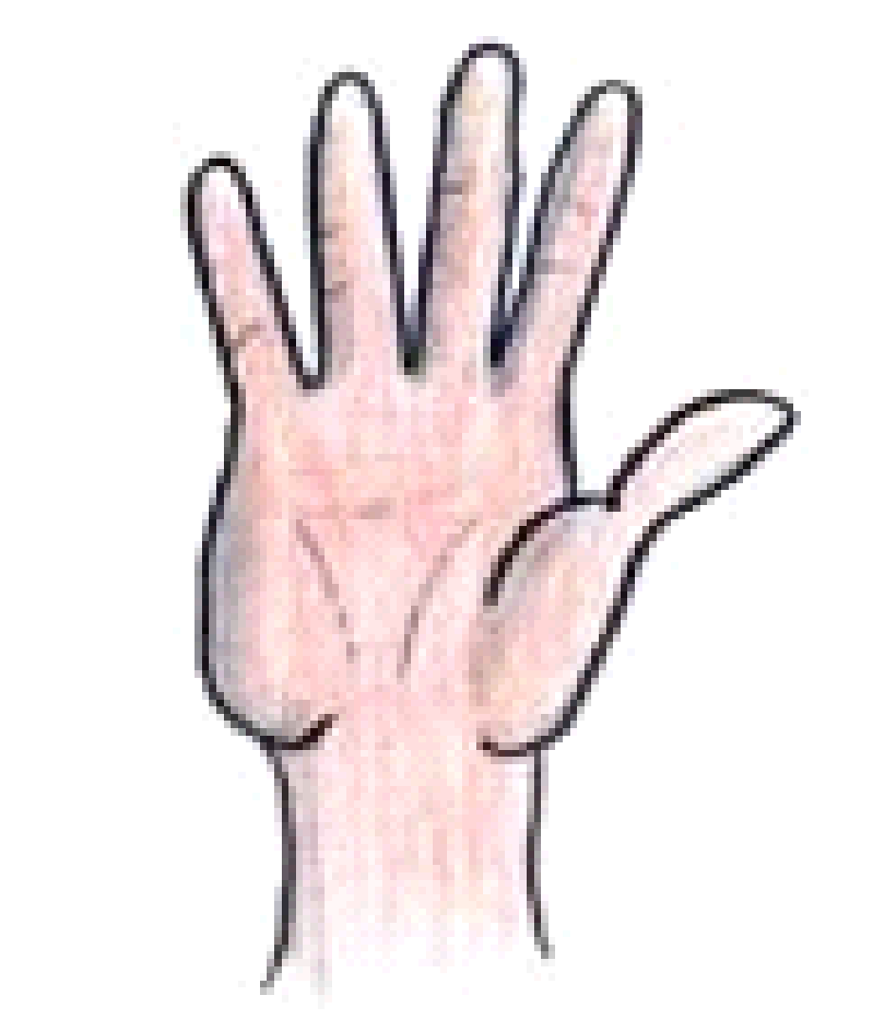 | 
 |  | 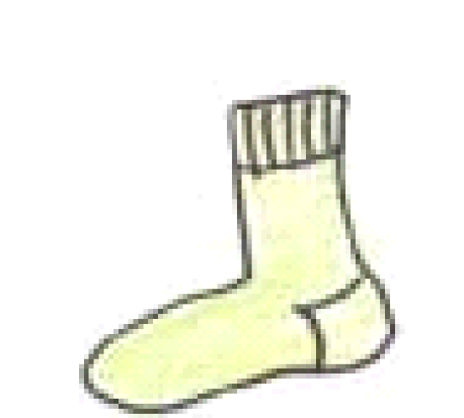 | 

Teaching Common Word Reading: 5 Part Strategy Helpsheet
Work on 3 to 5 common words at a time
Present words on flash cards / white board
Introduce one word at a time, using the Sequence of 5-Part Strategy

Sequence of 5-Part Strategy
Teacher model for 1) to 4)
- See & Say — Learner sees the word on the flash card and says the word while underlining it with finger.
- Spell Reading — Learner says the word and spells out the letters, then reads the word again.
- Arm Tapping — Learner says the word, then spells out the letters while tapping them on his arm, then reads the word again.
- Air Writing — Learner says the word, then writes the letters in the air in front of the flash card.
- Table Writing — Learner writes the letters on a table, first looking at and then not looking at the flash card.

This can also be done with a partner. TTYP and repeat the word and action. Thumbs up if correct.
A) Look at word. Discuss/ highlight tricky part.
B) 1) See & Say
- Read as underline word with finger. Repeat.
- My Turn Your Turn (MTYT)
- Model word in a sentence as run finger under word
- Learner rereads word a number of times as runs finger under word

2) Spell Reading
- Read the word as run finger under word
- Spell out using letter names as point to each letter
- Reread the word as run finger under word. Repeat all above.
- Learner repeats a number of times

3) Arm Tapping (stimulates kinaesthetic sense and provides tactile feedback)
- Read the word as model tapping shoulder with whole hand
- LOOK AT THE WORD and as say each letter name, use two fingers (index and middle) to tap down arm from shoulder to wrist
- Read the word as sweep 2 fingers along arm, from shoulder to wrist. Repeat all above.
- Learner repeats a number of times

4) Air Writing
- Hold flashcard up. Say the word while underlining it from left to right
- Air write under the written word, saying letter names as write
- Underline word again, saying word. Repeat all above.
- Learner repeats a number of times

5) Table Writing (sight word firming technique)
- Hold flashcard up
- Learner looks at the word. Learner:
  - reads word while making the left-to-right ‘underlining’ motion on
the table with first 2 fingers of writing hand
  - traces the word on the table while saying each letter name
  - reads the word again, making the underlining motion again on table
- Remove word
- Learner
  - traces word again, saying letter names
  - makes underlining motions on table while saying whole word

Review previous words using the See & Say method and common word reading booklet.
If word is read incorrectly use Correction Procedure and introduce word again using the sequence of 5 teaching techniques.

Correction Procedure
Adult: The word is Should. What is the word?
Child: Should.
Adult: Again. What is the word?
Child: Should.
Adult: Yes, Should
We should brush our teeth before bed.
What is the word?
Child: Should.
Reinforce learning with games.

Further strategies:
Segment Reading
If appropriate for word -
- Say word as underline it and read the word
- Break word into syllables, running finger under each syllable as say it. Repeat above.
- Learner repeats a number of times
- Read the word again clapping/ drumming/ playing on xylophone - each syllable. Repeat.
- Learner repeats a number of times

Colour Coding (visual association)
- Read as underline word with finger. Repeat.
- Learner repeats a number of times
- Compare to known word containing similar pattern/ words within word
- Colour similar patterns/ word within both words

Teach words with accompanying picture
- + draw small visual cues on flash cards in pencil. Rub picture off when able.

Teach words in context
- Point out/ find in sentences in reading book.

Multi-sensory Strategies (Make it fun)
- Sand writing
- Play dough words
- Use drum sticks to drum words on thighs/ fingers on table top
- Outdoor chalking
- Word walk – place words in a line on floor. Child reads each word as
move forward. If make it to the end, they win.
- Hop Scotch – place words on a hopscotch grid. Use bean bags. Read
words as play game
- Create songs that use the sight words. Display and sing every day

Precision Teaching - Reading (Common words)
For individuals who are making minimal progress using less intensive strategies

A structured method of daily monitoring and overlearning to develop an individual’s acquisition and fluency when learning to read words.

- Create a numbered list with 3 words the learner can read at the top, followed by words the learner consistently gets stuck on and requires extra reinforcement to master.

- Space the week’s dates along the top of the page.

- Write the first 5 words down the side of a jotter page.

- The learner reads each word twice at different points during the day e.g. start and end of lesson/ in school & at home.

- Mark with a dot or a tick.

- Following week – Take the top word off the list and add in next word on list. Mix up the words and write words downside of next jotter page.

Example:
Word list order
- they - known
- have - known
- what - known
- said - intermittent recognition
- each - unknown
- which - unknown
- their - unknown
- how - unknown
- about - unknown
- these - unknown

Week 1 17.1 18.1 19.1 20.1 21.1

they

have

what

said * * * *

each * * * * * * *

Week 2 24.1 25.1 26.1 27.1 28.1

what

said *

have

each * * *

which * * * * * *

Week 3 31.1 1.2 2.2 3.2 4.2

which * *

what

their * * * * *

said

each *

Simultaneous Oral Spelling (SOS)
This help sheet can be used as a quick reference during support sessions

- Teacher prints, saying letter names and says whole word
- Look at known phonics – sound out
- Look for tricky bit -highlight
- Learner repeats word
- Learner writes in joined script and says letter names and repeats word
- Learner does this 3 times
- Rub off learner’s words
- Teacher covers word
- Learner writes word and checks it is correct

Common Word Spelling-‘Nailed it’ Method, incorporating Simultaneous Oral Spelling

A retrieval practise technique -using flash cards to learn to spell common words
Give each learner 2 envelopes marked -
- Not yet
- Nailed it
Ask each learner to:
Day 1:
- SOS (on a whiteboard) the next 3-5 incorrect words from their Common Word
Spelling Booklet (words can also be chosen from elsewhere e.g. learner’s written work)

Day 2:
- SOS (on a whiteboard) the same 3-5 incorrect words from their Common Word
Spelling Booklet
- write each word on a flashcard and put the flashcards into their ‘Not yet’ envelope

Day 3:
Partner work:
- test each other by asking your partner to write each word from their ‘Not yet’ envelope (whiteboard)
- when a word is spelled correctly move it to the ‘Nailed it’ envelope.
- if incorrect put the word back in the ‘Not yet’ envelope
- SOS the words in your ‘Not yet’ envelope

Continue as for Day 3.
When the ‘Not yet’ envelope is empty go to Day 1 with new words.

*After 4 weeks, assess for retention of words using the Common Word Spelling booklet. If not retained, add back into the ‘Not yet’ envelope.

Precision Teaching – Spelling (Common words)
For individuals who are making minimal progress using less intensive strategies

A structured method of daily monitoring and overlearning to develop
an individual’s acquisition and fluency when learning to spell words

- Create a numbered list of words the learner consistently gets stuck on and requires extra reinforcement to spell correctly

- Teach and practise the first 3 – 5 words using Simultaneous Oral Spelling (SOS) on a whiteboard

- Use 2 pages of a jotter

- Space the week’s dates along the top of both pages
    - First page – write date twice from right to left
    - Second page – write date once from left to right (see below)

- Ask the learner to write the 3 – 5 words worked on down the right hand side of the first jotter page

- Support the learner to spell each word twice over the course of the day e.g. start and end of lesson/ in school & at home. Cover previous attempts e.g. by folding jotter page. Page 1 could also be completed on a whiteboard

- On the second page, mark with a dot or a tick.

- Reinforce correct spelling of dotted words.

- Following week – Take the top word off the list and add in next word on list. Present words in a different order

- Teach and practise the 3 – 5 words using Simultaneous Oral Spelling (SOS) on a whiteboard and continue to use Precision Teaching to monitor and develop learning

Example:
Word list order
- they - intermittently correct
- have - intermittently correct
- what - intermittently correct
- said - intermittently correct
- each - incorrect spelling
- which - incorrect spelling
- their - incorrect spelling
- how - incorrect spelling
- about - incorrect spelling
10 these - incorrect spelling

Pupils Spelling Page Fold line Fold line
21.1 21.1 20.1 20.1 19.1 19.1 18.1 18.1 l 17.1 l 17.1
they they they they they they l they l they l thay l they
l l l l
have have have have have have l have l have l have l hav
l l l l
what what what what what what l what l whot l whot l wot
l l l l
sed said said said sed said l sed l sed l sed l sed
l l l l
eech each each eech eech each l eech l eech l eech l eech
Page 1 could also be completed on a whiteboard

Week 1 17.1 18.1 19.1 20.1 21.1

they *

have *

what * * *

said * * * * * *

each * * * * * * *

Week 2 24.1 25.1 26.1 27.1 28.1

said * *

which * * * * * * * *

what

have

each * * * * *

Assisted and Independent Blending (for Reading)

Assisted Blending
Purpose
To support early readers in blending individual sounds into whole words using known phonemes only. This method reinforces phoneme–grapheme correspondence and oral blending skills.

Review Known Sounds
- Quickly revisit a few previously taught sounds
- Focus only on sounds the learner is secure with
- Flashcards or chart: Learners say each sound aloud → MTYT

Sound Talk the Word
Example word: mat

Exaggerate Sounds & Mouth Movements
- Teacher says: “Let’s sound talk… m – a – t”
- Learners repeat: “m – a – t” → MTYT
- Teacher says full word: “m – a – t... mat”
- Learners echo: “m – a – t... mat” → MTYT

Use Letter Cards
- Lay out the individual letter cards: m – a – t
- Point to each one while sounding out slowly
- Blend aloud while sweeping finger under: “mat”
- Repeat: point and sweep with learner → MTYT

Magnetic Board or Digital Tool
- Teacher builds the word with magnetic letters
- Point and sound out: m – a – t
- Sweep finger to blend: “mat”
- Repeat for clarity and consolidation

Learner Copies the Word
- Use magnetic board or an iPad magnetic letters app
- Learner builds m – a – t independently
- Points to each letter while sounding out
- Runs finger underneath to blend into full word → “mat”
- Repeat as needed for confidence

My Turn, Your Turn (MTYT)
- Use MTYT at every step to ensure repeated oral practice and engagement.

Independent Blending (for Reading)
Purpose
To develop learner independence in blending sounds to read real and non-words using known phonemes.
Instructions
- Select real words and non-words made up of previously taught sounds
- Ensure the learner is confident with the phoneme–grapheme correspondences used
- Gather magnetic letter/ cards required to make words
- Present the word silently
- Model whispering the sounds
- Example: j – a – m

Model
- Lay out letter cards or magnetic letters without saying the sounds
- Point to each letter and whisper the sounds: j – a – m
- Run finger under word and whisper the whole word: “jam”
This models the thought process without teacher-leading

Blending
- Learner builds the word (e.g. j – a – m) on their magnetic board or iPad app
- Learner points to each letter and whispers the sounds
- Runs finger under word and says the whole word quietly → “jam”
- Repeat as needed with different real and non-words

When learners can blend independently:
- Present written words (real and non-words) on flashcards
- Learners read them aloud without assistance
- Encourage quiet mouthing or whispering if needed

Continue using MTYT as a prompt if learners require occasional teacher-led support, but reduce over time to encourage full independence.

TIP – blending non words

Make and Break Spelling Help sheet

Multi-sensory approach to teach spelling of tricky/ common words
Useful strategy for spelling complex cross curricular words

- Give learner the word spelled out in plastic letters (or give letters on cards)
- Say the word and stretch is so that the syllables can be heard. e.g. innnn/ deeee/pennn/deeeeent
- Clap and say syllables in a rhythm. Do a few times.
- Work out how many syllables there are. If incorrect stretch out again.
- Ask learner to:
  - say word
  - physically split plastic letters into syllables
  - ‘syllable speak’ e.g. in/de/pen/dent OR
  - ask to say word and cut card up into syllables before syllable speaking.
(This could also be done by splitting word on paper with pencil e.g. ki/tten)
- Repeat syllables until firmly known
- Jumble the letters (or cut syllables into individual letters)
- Build the word saying the letter names as they are put in place i-n-d-e-p-e-n-d-e-n-t
- Split into syllables again and syllable speak.
- Repeat steps 7 to 9 as often as necessary.
- When the time is right (when success is very likely) ask to:
Look at the word very carefully (‘take a photo’ of it with your mind’)
Say (Can stretch it so the syllables can be heard)
Cover
Write and spell out
Check

Dictation Help Sheet.

Dictation steps

- Say sentence to learners.

- Learners repeat sentence - My Turn, Your Turn (MTYT)

As you repeat sentence:
- put emphasis on different words each time
- use mime as say word e.g. touch head as you say hat
- say sentence in different voices e.g. scary; whisper

4. Show the number of words on your fingers as you say each word
- State number of words in sentence as hold up fingers
- Model punctuation

- Continue, My Turn, Your Turn using above strategies until learners can remember the sentence easily

- If required, model writing of sentence on board:
- ask learners to show number of sounds in phonic word(s) using spelling fingers
- model use of Sound Chart to support spelling e.g. Which ‘ay’ grapheme am I using in this word?

- Hide sentence and repeat once more – MTYT

- Learners write sentence, read it back and check for errors. This can be completed on a whiteboard and then up levelled in a jotter.

- Self-correct sentence with learners e.g. ‘If you have a capital T starting your sentence tick above it.’ ‘If you have a finger space, give yourself a smiley face.’

Five Finger Test
A quick method to help learners choose a book at a suitable reading level and to check the reading level of a book

The learner chooses a book, they:
- open the book near the middle
- reads the page aloud
- puts one finger up for every word he/she does not know or can’t pronounce

- If the learner has five fingers up, the book is too difficult to read without help

- If the learner does not run out of fingers, but is reading very slowly and decoding almost every word, he/she will not understand or enjoy the book

Five finger guide
1 finger: This book is ok
2 fingers: Still good
3 fingers: Could give it a try but it could be a bit hard to understand
4 fingers: Could be too difficult to read and understand
5 fingers: Should choose another book

Three Read Strategy Help Sheet.
Individual Support
A strategy for teaching reading, focusing on the teaching of:
1) Decoding 2) Comprehension 3) Fluency and expression

- Introduce story - Talk around the theme/ story contents
- Discuss/ explain ‘tricky’ vocabulary
- Support to recognise (sound out/ break up) any ‘tricky’ words before reading

- Read 1 to decode independently
- Learner completes first read
- Support with decoding if required

- Read 2 to comprehend
- Model reading part of text while learner tracks
- ‘Think Out Loud’ – as read, model checking of own
understanding of text
- Refer to words/ phrases in text
- Ask questions and guide to look for answers in text / to infer from reading
- Learner re-reads text
- Learner reads on further. Discuss

- Read 3 for fluency & expression.
- Model reading with fluency and expression
- As reading, explain/ discuss expression by referring to motivation of characters; what’s happening; what they are thinking/ feeling/ saying
- Read to model use of punctuation and discuss its use to give meaning to text
- Learner re-reads text/ part of text
- Learner reads on further. Discuss
- Feedback on reading

Repeated Reading

Purpose
To develop accuracy, pace and fluency.
To develop decoding and ability to remember familiar words and syllable patterns.

In short:
- Read text to learner
- Talk about the text/vocabulary
- Point out hard words and get to repeat
- Discuss meaning of any words
- Read together 2-3 times
- Model/ discuss expression
- Learner reads text on own:
- Can get to take text away and ask to read to parent/ to teacher/ to friend in class/ read once a day till you work with them again

Next day (session)
- Learner’ performs’ poem = reads on own with expression.
- Do the above list with a new text.

This can also be completed with any passage of interest to the learner
The passage chosen should be somewhere between instructional and hard text level where possible. e.g. a passage from a recent novel; in-class text/ textbook / poem

Flash Card Games with minimal preparation
Using sounds, blends or word flashcards

- Face up pairs-find 2 the same.
- Snap.
- Memory – turn face down, pick 2 – if they match keep the pair or return to table.
- Flip –Lay face down, flip over with a fish slice and read/spell/ build an oral sentence.
- Splat – lay face up – splat named card with a fly swat
- Track game – use dice to move around the board reading flash cards at each turn.
- Find the Monster- put counters or pics of monsters under flashcards. Child says a word, checks under and collects counters/monsters until all cards have been read.
- Relay Race – One child stands apart from the group with word cards(captain). Group sends a runner to the captain who reveals the first letter and takes it back to the group. Another runner is sent to collect the next letter until the word is revealed (can be written on whiteboard)
- Pass the parcel – stand in a circle- pass the flashcards round – when adult says stop, child reads / spells / puts their word in a sentence.
- Word sort – lay out hoops or coloured spots. Sort the word cards by various criteria- number of letters, number of vowels, initial sound, certain sound. (eg, sh or ch)

Noughts and Crosses (cvc)

cat | had | bag
can | cap | fan
dad | cab | rag

get | den | red
let | bed | hen
web | bet | ten

bit | big | did
fit | rig | dig
dip | hit | hid

not | dog | got
cop | hot | cob
bog | pop | job

cut | cub | bug
hut | bun | hub
bud | but | jug

Noughts and Crosses Game template (x6)

Four in a Row. (‘th’ words)
1 | thick | them | there | that | this
2 | that | thick | moth | then | path
3 | them | this | than | with | that
4 | this | then | bath | there | that
5 | with | then | there | this | them
6 | thick | than | this | then | bath

Four in a Row. (‘th’ words) Instructions.
(2 player game)

Roll the die.
The number rolled = the row you must play in.

Read a word in that row.
If read correctly, place your counter on the word read.

Alternate turns.
First player to connect 4 words (horizontally, vertically, or diagonally) wins

Sharing Learning: Home School Link templates
This week I am learning to
- read and spell words with ______ in them
- spell the common words ___________________________
- write _________ using cursive script
My teacher wants you to know

This week I am learning to
- read and spell words with ______ in them
- spell the common words ___________________________
- write _________ using cursive script
My teacher wants you to know

