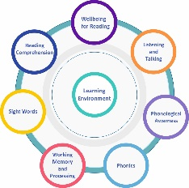
Individual Reading Discussion/Planning Tool - Access the full Reading Circle here on the Addressing Dyslexia Toolkit. This reflective tool provides opportunities for discussion, exploration and planning when considering the needs of learners who may be experiencing literacy difficulties. It can be used to record areas of
strength, difficulties and next steps. The collated information can be used within an identification pathway and to
evaluate progress within an agreed time scale.
Name |  | Class |  |  | School |  | Date
Wellbeing for Reading: - (Vision, Hearing ,Language development, Interrupted learning, EAL/Bilingual/, Reading Experiences). |  |  |  | Listening and Talking: - (Listening , Talking & Vocabulary)
Reading Comprehension |  |  |  | Phonological Awareness: (Words, Syllables, Rhyme, Phonemes).
Sight Words

Working Memory and Processing: - (Auditory processing, Visual Processing, Working memory) |  |  |  | Phonics
Learning Environment:

Next Steps:

