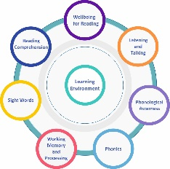
Establishment Reading Planning Tool - Access the full Reading Circle here on the Addressing Dyslexia Toolkit. This reflective tool provides opportunities to support effective planning when considering the needs of learners who may be experiencing literacy difficulties. Designed to be flexible, this tool can be used to discuss and evaluate supports, approaches and evidenced based programmes, to identify what is working well and why, what needs to improve, next steps and areas of required professional learning. The collated information can be used to support evidence based improvement planning.

Establishment/faculty/ department/class |  |  | Date
Wellbeing for Reading: - (Vision, Hearing ,Language development, Interrupted learning, EAL/Bilingual/, Reading Experiences). |  | Listening and Talking: - (Listening , Talking & Vocabulary)
Reading Comprehension |  | Phonological Awareness: (Words, Syllables, Rhyme, Phonemes).
Sight Words

Working Memory and Processing: - (Auditory processing, Visual Processing, Working memory) |  | Phonics
Learning Environment:

Next Steps:

