Addressing Dyslexia Toolkit - Professional Reflection and Planning Tool:  Transitions  This professional reflection and planning tool support opportunities to reflect on your knowledge and understanding of the areas highlighted within the Addressing Dyslexia toolkit and help you plan the next steps in your professional learning. |  |  |  |  |  |  | 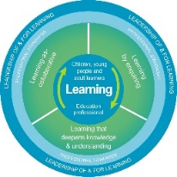
Name |  |  | Establishment |  |  | Date
Toolbox Focus area |  | My reflections on this section |  |  | My next steps and priorities for my professional learning.
Transitions - Macro
Transitions Micro
Covid 19

Reflective Prompts | Next Steps and Priorities for my Professional Learning.
How well does my planning and support reflect the transitional needs of my learners? Do I take account of the wide range of transitions learners experience – Macro and Micro?
How do we know as a school community know that our ethos, practice and policies support the range of transitions our learners experience? Do we take account of the wide range of transitions learners experience – Macro and Micro?

