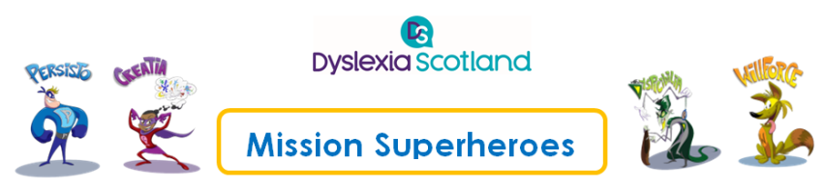
Ambassador Outreach Programme
Superhero Characters
Character | Strengths | Challenges
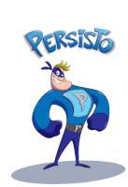  Persisto | - Determined to succeed – highly driven and ambitious  - Resilient | - Won’t ask for help when it’s needed  - Aims for the top but doesn’t want to take the steps in between  - Gets frustrated and pushes others away
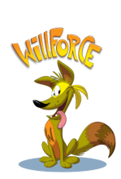  Willforce | - Caring and thoughtful  - Tuned in to how others feel  - Emotionally intelligent | - Doesn’t believe in himself  - Can’t recognise own strengths  - Finds it really hard to be organised
Creatia | - Sees things others don’t  - Artistic and expressive through art and music  - Thrives when allowed to think and act creatively | - Sensitive to criticism and lets sad feelings get in her way  - Doesn’t remember to use her creative strengths in difficult situations
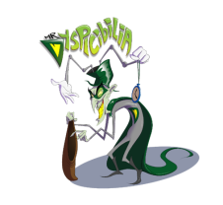  Dyspicabilia | - Becomes more powerful by feeding off others’ negative thoughts | - Powerless against a growth mindset and positive thinking

