Route Map through Career Long Professional Learning (CLPL) for Dyslexia and Inclusive Practice
This professional learning resource is a route map for Dyslexia and Inclusive Practice. Developed in response to Recommendations 1 and 2 of the 2014 Education Scotland Review Making Sense: Education for Children and Young People with Dyslexia in Scotland. As per the recommendations within the 2014 review, this route map has been developed in partnership with Education Scotland, Dyslexia Scotland, The Addressing Dyslexia Toolkit and stakeholders.

“Education Scotland should work with Dyslexia Scotland and other relevant stakeholders to develop a comprehensive dyslexia professional learning package which can be used by local authorities to increase the capacity of teachers to meet learning needs.”
“1. Teachers, support staff, learners and parents should have access to up-to-date practical advice and guidance on dyslexia.
2. Teachers, support staff and local authority staff should have access to a wide range of high-quality career-long professional learning opportunities at school, local and national level related to meeting the needs of children and young people with dyslexia.”

Aims
- To develop a route map to support deeper learning and understanding of dyslexia and Inclusive practice.
- To encourage all teachers to be familiar with, and make appropriate use of, the Addressing Dyslexia Toolkit.

Achieving successful outcomes for Scotland’s children and young people
The “Making Sense” review highlights why there is a need to improve on the outcomes for children and young people with Dyslexia. This is one of a number of professional learning resources developed for teachers, schools and local authorities.
Qualifications attained by young people with dyslexia
Young people with dyslexia achieve significantly less well academically than their peers.
A negative gap of between 20% and 30% exists between the attainment of young people with dyslexia and young people who do not have additional support needs in qualifications equivalent to Intermediate 2 and Higher. Overall, the tariff score shows that young people with dyslexia achieve their set of qualifications at a level which is less than 60% of the national average.

Post-school destinations
Young people with dyslexia attain significantly less well than their peers.
Only 17% of young people with dyslexia have the opportunity to apply for Higher Education compared to 44.2% of their peers with no additional support needs.

Contents | Page
Hot Topics – Questions to encourage professional dialogue and reflection

Dyslexia Scotland and the Addressing Dyslexia Toolkit

Career- Long Professional Learning (CLPL) in Dyslexia and Inclusive Practice

- Pedagogy, Learning and Subject Knowledge - Dyslexia and Inclusive Practice
- Curriculum and Assessment
- Enquiry and Research - Literature review
- Sustaining and Developing Professional Learning
- Learning for Sustainability – equality and capacity building within the educational establishment/system

Summary /Conclusion

Hot Topics
Questions to Encourage Professional Dialogue and Reflection

- Why does Inclusion matter?
- Should the focus and resources be used on the identification or label of dyslexia or should schools concentrate on meeting the needs of the child and young person through a collaborative process?
- What are the most appropriate teaching methods to support our dyslexic learners in reading and do they need alternative resources?
- Should teachers in Scotland be required to participate in training to carry out the identification of dyslexia?
- Should teachers in Scotland be required to gain qualifications to carry out the identification of dyslexia?
- How should independent assessments of dyslexia be regarded and supported within schools and what is the legal status of independent assessments?
- Are the roles of identification and tracking for dyslexia understood within Assessment is for Learning? Is it understood that when meeting learners’ needs the assessment of learning informs the next steps and should be continuous and separate from ‘identification’ of dyslexia? The label alone will not provide appropriate support; this is achieved by regular tracking and reviewing of learners needs.
- Can the identification process for dyslexia be a positive experience for children and young people? Does the process enable them to understand their strengths and difficulties in a supportive approach and provide opportunities for their views to be sought?
- Are children and young people, teachers and parents/carers provided with appropriate information/feedback to support their understanding of which approaches/strategies are effective and why?
- How can young people be encouraged to develop their responsibility in working towards independent learning?
- Are children and young people able to access an accessible curriculum with CfE and are children encouraged to present their learning, demonstrate their cognitive ability in a range of formats.
- How well are the health and well-being/emotional aspects of dyslexia addressed in your school?
- What should a young person do if their parent doesn’t want dyslexia to be identified?
- How do you support and facilitate achievement and attainment improvements for children and young people?
- How do you support the Core Skills within Curriculum for Excellence?

Dyslexia Scotland and the Addressing Dyslexia Toolkit

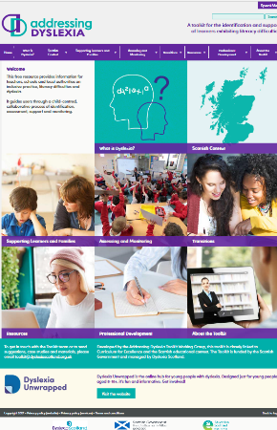

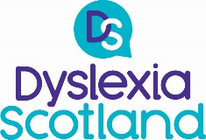

Dyslexia Scotland aims to encourage and enable children, young people and adults with dyslexia to reach their potential in education, employment and life. Based in Stirling with a network of volunteer-led branches across Scotland, it offers high quality services to people with dyslexia and those who support them. Dyslexia Scotland aims to influence and achieve positive change at national and local levels.

The Addressing Dyslexia Toolkit is the free national online resource developed for practitioners, schools and local authorities. It is funded Scottish Government and under the management of Dyslexia Scotland to provide information and support to help meet their learners’ needs http://www.addressingdyslexia.org.
Refreshed in 2017 it is a resource for all who work with pre-school and school-age children and young people in a professional educational setting and seeks to reassure that dyslexia is not a mystical or mythical problem that only specialist highly trained individuals can deal with. Everyone has the skills and abilities to recognise early signs of dyslexia in children at all stages and take appropriate action in response to support children and young people.
A key aim of the toolkit is to highlight to all class teachers that they are in the best position to identify early indicators of dyslexia and other literacy difficulties. The toolkit:
- Provides up to date information on dyslexia for teachers and local authorities set within the context of Scottish education.
- Offers an identification pathway built on Curriculum for Excellence and which supports GIRFEC for all teachers to follow, enabling them to ensure that appropriate collaborative assessment and support are in place for learners with literacy difficulties such as dyslexia when they need it.
- Offers guidance on the collaborative process of assessing literacy difficulties, which may be dyslexia.
- Provides details of relevant approaches and strategies, using free sources wherever possible.

Throughout the “Making Sense” review, use of the Toolkit is recommended for all teachers and local authorities. The toolkit was created within the Scottish education, inclusion and equality legislative framework.

Professional Learning

The Scottish teaching profession is committed to career-long professional learning (CLPL). Information about the nature and purposes of CLPL can be found in the 2012 GTCS publication which can be found at
http://www.gtcs.org.uk/web/FILES/the-standards/standard-for-career-long-professional-learning-1212.pdf

The Standard for Career-Long Professional Learning describes the advanced professional knowledge and pedagogical expertise that registered teachers will develop and maintain as they continue to progress in teaching and the education profession. The standard provides an opportunity for teachers to progress, enrich, develop and enhance their practice, expertise, knowledge, skills and professional values.

The Standard for Career-Long Professional Learning: supporting the development of teacher professional learning’ (GTCS 2012) identifies CLPL as:

- Pedagogy, learning and subject knowledge
- Curriculum and assessment
- Enquiry and research
- Educational contexts and current debates in policy, education and practice
- Sustaining and developing professional learning
- Learning for sustainability

This route map will use the GTCS CLPL focus areas to support professional learning for Dyslexia and Inclusive Practice.

The National Model of Professional Learning
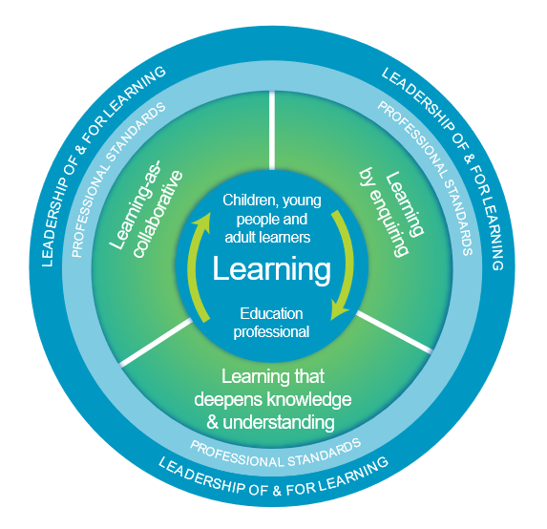
As education professionals you engage in professional learning to stimulate your thinking and to ensure your practice is critically informed and up-to-date. The national model of professional learning identifies the key principles and features of effective learning that will build capacity and promote collaborative practices. The model provides a shared language and aspiration, informing the provision, structure and nature of learning. It also outlines the kinds of learning that will empower and enable you to best meet the needs of learners.

Further information on the national model of professional learning can be found at https://education.gov.scot/professionallearning

Learning for sustainability
The Impact of Dyslexia
What is the Scottish
Perspective?
Dyslexia and Inclusive Practice

Dyslexia and Inclusive Practice

Dyslexia
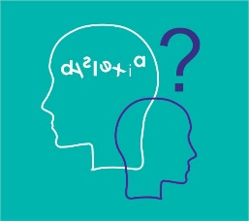

The human population is highly diverse. Neurodiversity is a term that describes this normal variation across all people. Dyslexia is a lifelong neuro-developmental difference. At all stages, dyslexia is on a continuum varying from mild to severe, with a range of strengths and difficulties and, according to the nature of the activity undertaken, the learning environment and any coping strategies and support in place. As a result, every individual with dyslexia will differ in the range of factors that are affected and in the level of severity experienced. There is however a common set of signs that can be observed, and these are referred to as characteristics and are in the Scottish working definition.

Scotland’s ‘needs led’ approach does not require a ‘label’ of dyslexia to be in place before support is provided but it is important to recognise that for individuals and their families the term ‘dyslexia’ can support their understanding of what dyslexia means for them. Identifying dyslexia as early as possible will support future learning, teaching and wellbeing.

A Scottish working definition of dyslexia was developed in 2009 by the Scottish Government, Dyslexia Scotland, the Cross-Party Group on Dyslexia in the Scottish Parliament and a wide range of stakeholders. It is one of many definitions available and is recommended as helpful guidance by Education Scotland for local authorities, educational practitioners, children, parents/carers and others to provide a description of the range of indicators and characteristics of dyslexia.

Scottish Working Definition of Dyslexia, 2009
The following working definition of dyslexia has been developed and agreed by the Scottish Government, Dyslexia Scotland and the Cross-Party Group on Dyslexia in the Scottish Parliament. The aim of this particular definition is to provide a description of the range of indicators and characteristics of dyslexia as helpful guidance for educational practitioners, learners, parents/carers and others.
Dyslexia can be described as a continuum of difficulties in learning to read, write and/or spell, which persist despite the provision of appropriate learning opportunities. These difficulties often do not reflect an individual's cognitive abilities and may not be typical of performance in other areas. The impact of dyslexia as a barrier to learning varies in degree according to the learning and teaching environment, as there are often associated difficulties such as:
- auditory and /or visual processing of language-based information
- phonological awareness , oral language skills and reading fluency
- short-term and working memory
- sequencing and directionality
- number skills
- organisational ability
Motor skills and co-ordination may also be affected.

Dyslexia exists in all cultures and socio-economic backgrounds.
It is a hereditary, life-long, neurodevelopmental condition.
Unidentified, dyslexia is likely to result in low self-esteem, high stress, atypical behaviour and low achievement.
Learners with dyslexia will benefit from early identification, appropriate intervention and targeted effective teaching, enabling them to become successful learners, confident individuals, effective contributors and responsible citizens.

The Scottish Context
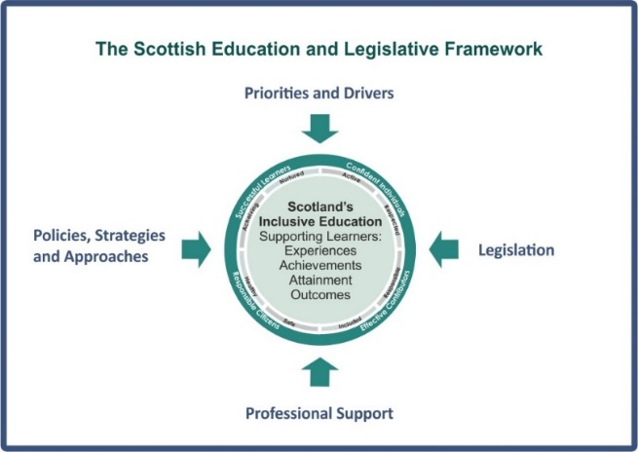

Scotland’s ‘needs led’ and rights based educational system is designed to be an inclusive one for all children and young people in Scottish schools, with or without additional support needs. It is not dependent upon a formal label such as dyslexia, autism, physical disability or mental health. This inclusive approach not only allows children and young people to thrive in their community but also contributes to all children and young people’s understanding and appreciation of diversity and helps to build a more just society.

Children’s rights and entitlements are fundamental to Scotland’s approach to inclusive education supported by the legislative framework and key policy drivers. These include Curriculum for Excellence, the Getting it right for every child approach and the Framework for Professional Standards for teachers. These are underpinned by a set of values aligned to social justice and commitment to inclusive education. The image above provides an overview of this Scottish context. Annex A provides further details.
Our legislation ensures rights and entitlements for children and young people to education, support and wellbeing. There is a range of legislation and educational policies that places duties and expectations on schools and local authorities to ensure that they:
- deliver an inclusive education
- support learners to achieve to the best of their ability
- do not discriminate against those with protected characteristics
- provide assessments when requested.

Inclusive practice
Reflection
  - What does inclusion mean?
A range of definitions have been developed and these contribute to an understanding of inclusive education. Consider how they reflect the education establishment you support or work in.
The Scottish Government vision for inclusive education states that:
'Inclusive education in Scotland starts from the belief that education is a human right and the foundation for a more just society. An inclusive approach which recognises diversity and holds the ambition that all children and young people are enabled to achieve to their fullest potential is the cornerstone to achieve equity and excellence in education for all of our children and young people’.
The Scottish Government, Excellence and Equity for All: Presumption to provide education in a mainstream setting: Guidance (2019), p. 4
Equality is the removal of discrimination, disadvantage, inequality and / or barriers which can affect people on the grounds of the protected characteristics set out in the Equality Act 2010: age, disability, gender reassignment, marriage and civil partnership, pregnancy and maternity, race, religion or belief, sex and sexual orientation.
Equity means treating people fairly, but not necessarily treating people the same.
Equity in education means that personal or social circumstances such as gender, ethnic origin or family background are not obstacles to achieving educational potential and that all our young people are well supported to secure wellbeing, skills for learning, life and work and the best possible post-school destination, HGIOS 4 (2016). Equity is generally understood to refer to fairness and impartiality for people in general and sometimes especially relating to fairness for people facing socio-economic disadvantage

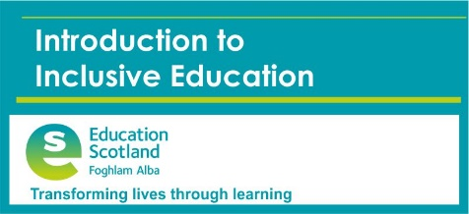
Free online professional learning modules on inclusive education is available the Education Scotland National Improvement Hub.

https://education.gov.scot/improvement/self-evaluation/inc84-inclusive-education/
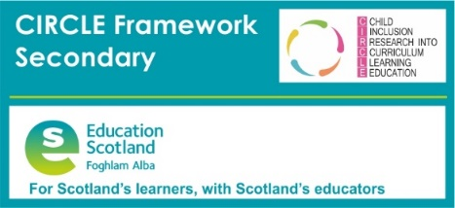

https://education.gov.scot/improvement/learning-resources/inclusion-in-practice/
Staged Levels of Intervention

Staged intervention is used as a means of identification, assessment, planning, recording and review to meet the learning needs of children and young people. Staged intervention is designed to be flexible and allows for movement between stages depending on progress.

It provides a solution-focused approach to meeting needs at the earliest opportunity and with the least intrusive level of intervention. The process involves the child, parents/carers, school staff and, at some levels, other professionals, working in partnership to get it right for every child.

Universal Support
Universal support starts with the ethos, climate and relationships within every learning environment. It is the responsibility of all practitioners to take a child-centred approach which promotes and supports wellbeing, inclusion equality and fairness. The entitlement to universal support for all children and young people is provided from within the existing pre-school and school settings.

An environment which is caring, inclusive, fair and focused on delivering learning to meet individual needs will encourage all children and young people to strive to meet their learning potential. Every child and young person is entitled to support to enable them to gain as much as possible from the opportunities which Curriculum for Excellence can provide. When a child or young person may require some additional support, this is initially the responsibility of the classroom teacher. The majority of children and young people’s needs are met through universal support.

Some examples of universal support are below – this list is not exhaustive.

- Personalised learning plans
- Literacy, numeracy or health and wellbeing support
- Enhanced transition e.g. P7 – S1
- Use of ICT e.g. digital learning and teaching resources such as digital SQA exams
- Quiet spaces
- Visual time tables

Targeted support

Children and young people can benefit from additional or targeted support, tailored to their individual circumstances. This could be at any point on their learning journey or throughout the journey.

This targeted' support is any focused support which children or young people may require for short or longer periods of time to help them overcome barriers to learning or to ensure progress in learning.
Targeted support is usually, but not exclusively, co-ordinated and provided by staff with additional training and expertise through a staged intervention process. This may be by staff other than the class teacher and outwith the pre-school or school setting but within education services
In a secondary school, this support may be coordinated by guidance/pastoral care/pupil support staff. .

Some examples of targeted support are below – this list is not exhaustive.

- Higher attaining children (ensuring progression)
- Bereavement peer support group
- Input from Allied Health Professionals e.g. speech and language
- Specific learning difficulties
- Trauma informed interventions designed for a care experienced child/young person
- Complex needs e.g. sessions in a sensory room

Scottish Perspective on Dyslexia
In Scotland, research on dyslexia has produced a body of literature which investigates the nature, causes and approaches that can effectively ease the barriers to learning experienced by children and young people with dyslexia. For example, neuroscience research through brain imaging has identified diversity in the brain for adolescents and for those with dyslexia. There is no shortage of understanding of both the cognitive and the biological aspects of dyslexia (Elliot, Davidson & Lewin, 2007). Most sources of evidence lead to the conclusion that dyslexia is rooted in difficulties associated with language, particularly phonological processing. Overall, researchers and professionals are still at an early stage in the journey toward understanding how to meet effectively the needs of learners with dyslexia. This ongoing research should ensure more positive outcomes for children and young people with dyslexia in the future (Sawyer, 2006). Making Sense Review 2014

Dyslexia is a Specific Learning Difficulty and a recognised disability under the Equality Act (formerly the Disability Discrimination Act). Dyslexia is both hereditary and life-long and affects both children and adults. It is estimated that one person in ten is dyslexic in Scotland (approx. 550,000), with 1 in 4 of those 10 (2.5%) classed as severely dyslexic.

Over time a range of terms and definitions have been developed and may still be used in some countries to describe dyslexia:
- Developmental dyslexia
- Congenital word blindness
- Reading disability
- Reading disorder
- Specific learning difficulty
- Phonological dyslexia
- Learning difference
- Learning difficulty

The 2009 Scottish Government working definition of dyslexia was agreed and this provides an overview of the wide range of characteristics which may be experienced by individuals who are dyslexic. It is helpful to understand and view Dyslexia as a learning difference not a learning difficulty. There is no typical dyslexic profile, but there are characteristics which are commonly associated with dyslexia. It is important to remember that the child or young person must be placed at the centre of the planning for identification, support and intervention and to ensure that their strengths and views will also be key focus areas.

Common strengths which can be experienced by individuals with dyslexia
- Can be very creative and enjoy practical tasks
- Strong visual thinking skills e.g. seeing and thinking in 3D, visualising a structure from plans
- Good verbal skills and good social interaction
- Good at problem solving, thinking outside the box, seeing the whole picture.

Common areas of difficulty which individuals with dyslexia can experience which can impact on their learning

- Phonological Awareness
- Short-term memory
- Working memory
- Naming and labeling
- Processing speed
- Organisation
- Automaticity Th Impact of Dyslexia

The Impact of Dyslexia

Dyslexia impacts on parents, families and carers who become distressed that their dependents cannot get the support they need. In both children and adults, when dyslexia is unidentified or unsupported the negative impact can be high – children often lose motivation and become frustrated through the stress of trying to learn, not understanding what dyslexia is and knowing that there are ‘different’ to others because they find difficulty in doing what to others are simple tasks. This can lead to acute behavioural problems both at school and at home including bullying and anti-social behavior, as well as overall severe low self-esteem and frustration for children and adults not reaching their potential.
The impact on adults whose dyslexia is not identified and supported can be under achievement in further education and employment. The negative effects of dyslexia on self esteem and confidence can lead to high stress levels, damage to personal relationships, day to day difficulties, depression and mental health problems. There is an established link between offenders and dyslexia. It is estimated that over 60% of prisoners have literacy difficulties, mainly dyslexia.
People with dyslexia will benefit from early identification, appropriate intervention and targeted, effective support at the right time.

Curriculum and Assessment

What are Dyslexia and Inclusive Friendly Approaches
?
Who identifies dyslexia?
How is dyslexia identified?
What is an inclusive and accessible curriculum?

What is an inclusive and accessible curriculum?

Curriculum for Excellence

Supporting children and young people within the curriculum

The original report of the Curriculum Review Group, A curriculum for Excellence (Scottish Executive, 2004) indicated that all children and young people should be successful learners, confident individuals, responsible citizens and effective contributors to society and at work. By providing accessible structure, support and direction to young people's learning, the curriculum should enable them to develop these four capacities. The curriculum should complement the important contributions of families and communities.

The design principles which schools, teachers and other educators should use to develop and implement the curriculum are:
- Challenge and enjoyment
- Breadth
- Progression
- Depth
- Personalisation and choice
- Coherence
- Relevance

Within Curriculum for Excellence, personal learning planning is at the heart of supporting learning. The conversations about learning, reviewing progress and planning next steps are central to this process. Planned opportunities for achievement which focus on the learning and progress made through activities across the full range of contexts and settings in which the curriculum is experienced also contribute to the universal aspect of support. It is the responsibility of all practitioners and partners to deliver this universal entitlement within their own teaching environments.

“In addition, all children and young people should have frequent and regular opportunities to discuss their learning and development with an adult who knows them well and with whom they have a mutually trusting relationship. This key member of staff has the holistic overview of the child or young person’s learning and personal development”.
Appendix 2 ‘Making Sense Review’

Every child and young person is entitled to support to enable them to gain as much as possible from the opportunities which Curriculum for Excellence can provide. When it is felt that a child or young person may require some additional support this is the initial responsibility of the classroom teacher.

Responsibility for all – Curriculum for Excellence

All staff have a responsibility to develop, reinforce and extend learning in the following areas:

- Health & Wellbeing - Some aspects of the health and wellbeing framework are the responsibility of all adults, working together to support the learning and development of children and young people

- Literacy - All practitioners are in a position to make important contributions to developing and reinforcing young people’s literacy skills.

- Numeracy - Numeracy across learning provides essential analytic, problem solving and decision making skills across the curriculum. The numeracy across learning experiences and outcomes are a subset of those found in the mathematics curriculum area.

Supporting health and wellbeing is important for all learners. However, for those who experience barriers to learning it is crucial that this aspect is included within the identification and support process. Dyslexia impacts on all three areas of responsibility for all and will impact in varying degrees and in various ways depending on the individual learner. Staff can make a difference and support learners irrespective of the sectors or subject which is being taught.
The Curriculum for Excellence: Health and Wellbeing principles and practice highlight that it is the responsibility of all practitioners to:
- establish open, positive, supportive relationships across the school community, where children and young people will feel that they are listened to
- create an environment where children and young people feel secure in their ability to discuss sensitive aspects of their lives
- promote a climate in which children and young people feel safe and secure
- model behaviour which promotes health and wellbeing and encouraging it in others
- use learning and teaching methodologies which promote effective learning
- be sensitive and responsive to the wellbeing of each child and young person

The Inclusive Curriculum
Curriculum Accessibility

The curriculum includes all of the experiences which are planned for children and young people through their education. It is not specific to subject areas but applies to activities that take place across the school.

A curriculum which is accessible to all learners enables schools and education authorities to :

- Fulfil statutory duties and professional responsibilities
- The needs of their learners, including those without Additional Support Needs, but who can also learn effectively from appropriately planned and developed resources
- The standards for Curriculum for Excellence
- Provide effective management and self-evaluation - Cost effective use of time through appropriate planning – Use of IT, production of accessible digital resources which enable swift adaptation for different learners

Accessibility Strategy

This legislation supports all learners with disability including ‘hidden’ disabilities:
- Dyslexia
- Autism
- Speech and language impairment
- Term ‘significant’ – more than minor or trivial

The Equality Act includes a duty to make reasonable adjustments, of three types:
  - Change the practice (for example, providing a pupil with dyslexia with a note of any homework required rather than requiring him to copy it down);
  - Change the built environment (for example, providing access to a building) where it is reasonable to do so; and see Equality Act S20(4)
  - Provide auxiliary aids and services (for example, providing special computer software or support from a classroom assistant).
  - Also, if the first or third relates to information to provide it in an accessible format.

Accessibility Strategy Guidance 2014 – summary
http://www.gov.scot/Publications/2014/10/8011

Differentiation
The impact any additional support need has on learning varies in degree according to the learning and teaching environment. It is the responsibility of all who work with children to respond appropriately to their needs. Recognising early signs of difficulties and adapting learning and teaching approaches are a regular part of the daily routine for teachers supporting all children in an educational environment.

Differentiation is defined by the Training and Development agency for Schools as:
the process by which differences between learners are accommodated so that all learners in a group have the best possible chance of learning.

Differentiation is a key skill and requirement for all teachers to ensure the needs of all their learners are met. Creating resources, which are accessible for learners with additional support needs, will also support a wide range of learners. The impact a barrier to learning has varies in degree according to the learning and teaching environment. To ensure learners can access the curriculum and engage with the learning and teaching, staff will need to make adaptations and differentiate their approaches and resources and this may happen in a number of ways. Expert opinion varies regarding agreement on the definitive methods and approaches to support differentiation within learning and teaching, for example Kormos and Smith (2012) highlight that effective differentiation can be achieved by considering four dimensions: materials, task, expectation and support. (Teaching Languages to Students with Specific Learning Difficulties: 2012) and others focus on the areas of

- task
- support and
- outcome.
The image above highlights different approaches to consider when planning effective and meaningful differentiation. There are several categories to consider when planning effective and meaningful differentiation.

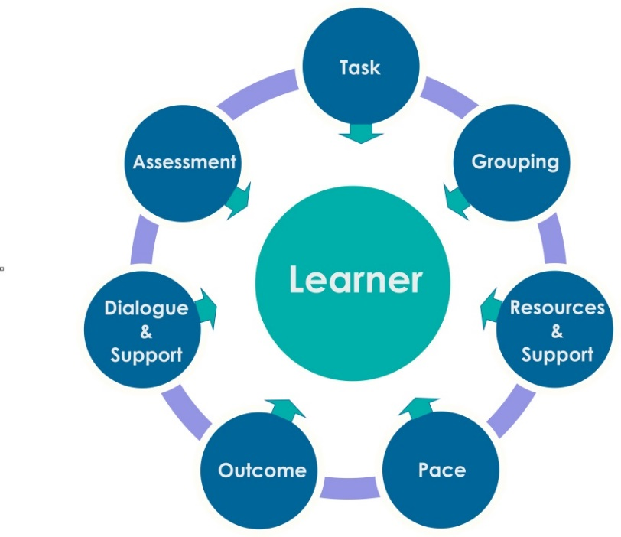

Differentiation by: | Areas of focus for differentiation
Task | - Designing learning and teaching tasks for different abilities  - Ensuring appropriate challenge is included  - Designing learning and teaching which become progressively harder and more complex for the learner to engage with and complete.
Grouping | - Co-operative learning approaches and activities which encourage the participation of all learners in the learning activity  - Small mixed group abilities  - Peer support and learning
Resources /Support | - Consideration of developing and supporting the learner’s independent skills  - Resource accessibility - consideration of resource design e.g. choice of formats diagrammatic, visuals, digital, audio and film  - Range of formats to record pupils cognitive ability and evidence of learning  - Readability levels within textbooks and resources  - Provision of printed notes/resources or electronic files  - Provision of key words/glossaries  - Staff, family and peer support
Pace | - Consideration of flexibility of teaching pace and time allowed for tasks and individual pupil requirements, supporting both able learners and those who require more time.
Outcome | - All students undertake the same task but a variety of results are expected and are acceptable.
Dialogue and support | - Teacher facilitates problem solving using appropriate levels of language to engage with learners  - Use of targeted questions to produce a range of responses  - Verbal support and encouragement
Assessment | - 'Building the Curriculum 5' (2011) provides guidance for all teaching staff on the main areas of the assessment strategy for Curriculum for Excellence.  - Assessment is for Learning -  - Ensuring appropriate support for all learners  - Summative assessment techniques  - Assessing learner’s knowledge and understanding through the learning experience.

Dyslexia and Inclusive Friendly Approaches

Neil Mackay developed the ‘Dyslexia Friendly Schools’ concept in 1998. Key aims of Dyslexia Friendly schools were to enhance the impact of learning and teaching on the child in the classroom and to ensure that teaching was multi-sensory and benefited all children, not just those with dyslexia. The approach has developed over the years and is inclusive and holistic, reflecting current research on effective positive learning for children with literacy difficulties.

The Making Sense report highlighted the positive impact on the school community when they became Dyslexia Friendly. Key aims of Dyslexia Friendly schools are to enhance the impact of learning and teaching on the child in the classroom and to ensure that teaching was multi-sensory and benefited all children, not just those with dyslexia. The approach has developed over the years and is inclusive and holistic, reflecting current research on effective positive learning for children. A number of Kite marked Dyslexia Friendly School accreditation schemes have been developed which schools and local authorities can choose to participate in.
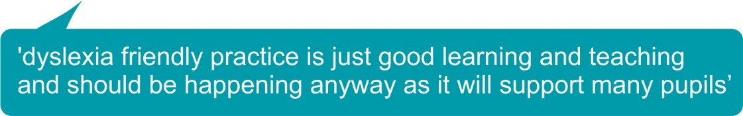

Making Sense programme consultation/conversation events outcomes
Stakeholder participation and feedback highlighted the following points:
- Improving inclusive practice should be the main focus and not the development of an award for dyslexia friendly schools.
- The features of Dyslexia friendly schools should already be evident in all schools and monitored through existing effective self-evaluation. For example, using ‘How Good is Our School 4?’ (HGIOS 4) and ‘How good is OUR School’.
- Achieving recognition for inclusive practice should not incur unnecessary bureaucracy and neither should it be a ‘tick box’ process.
- Developing and embedding inclusive practice should be a process which reflects familiar language and current practice to achieve improvement – reflective practice, partnership, collaboration and self-improvement.

Stakeholders highlighted eight key areas which would improve the outcomes for learners with dyslexia through effective inclusive practice. The selection of these key areas to support improvements in inclusive practice is also supported by a range of evidence from inspection, research and project work carried out by the European Agency for special Needs and Inclusive Education.

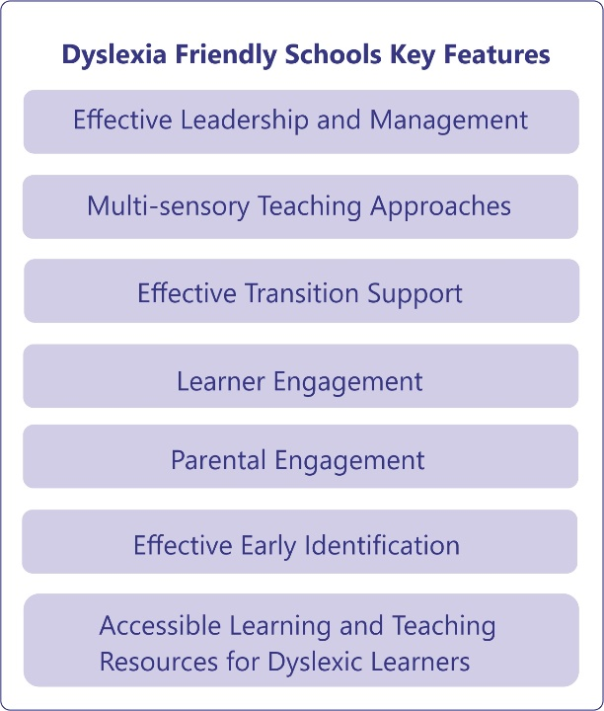
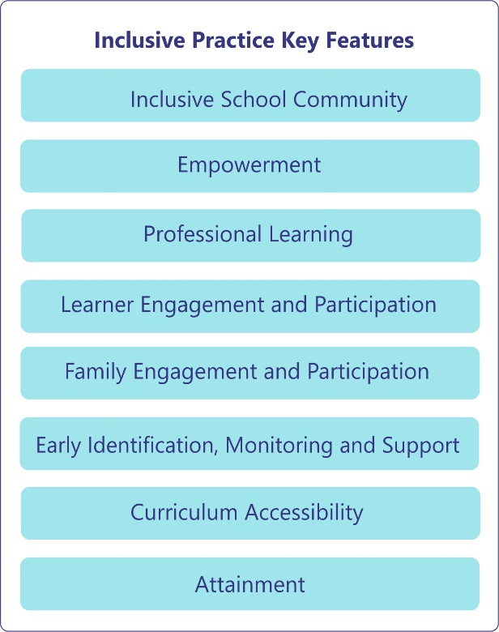

The images above highlight the close correlation of key features of Dyslexia Friendly Schools and Inclusive Practice.
Dyslexia and Inclusive practice = Learning friendly approaches - All learners - with and without Additional Support Needs - are effectively and successfully supported using learning and teaching strategies which focus on appropriate dyslexia friendly approaches embedded within good teaching practice.

How is dyslexia identified?

Early identification, monitoring and support
The Making Sense report highlighted the importance of early identification to ensure learners progress and achieve to their maximum potential. Effective assessment monitoring and support mechanisms are essential to identify the support needs of learners at an early stage.

Scotland’s education system is designed to be an inclusive one for all children and young people in Scottish schools, with or without additional support needs.
Scotland’s ‘needs led’ and rights based educational system places the learner at the centre and the provision of support is not dependent upon a formal label such as dyslexia, autism, physical disability or mental health. However, this does not mean that there is no requirement to appropriately identify dyslexia. Identifying dyslexia as early as possible will support future learning, teaching and wellbeing. It can be extremely important to individuals and their families that the term ‘dyslexia’ is used appropriately as it can support their understanding of what dyslexia means for them.
It is the responsibility of all who work with children to respond appropriately to their needs. Recognising early signs of difficulties and adapting learning and teaching approaches are a regular part of the daily routine for teachers of all children in an education environment. Parents, carers and children over 12 years old have the legal right to request an assessment and this should be started with 6 weeks of the request.
Assessing dyslexia and providing appropriate support are symbiotic processes. See also information in the Supporting learners and Families section within the Toolkit on Initial steps and Starting the process.
The assessment of dyslexia in children and young people in schools in Scotland:
- Is a process rather than an end-product. The information provided in the assessment should support the learner’s next steps for learning.
- Should be a holistic and collaborative process which takes place over a period of time, drawing on a range of observational and assessment methods. This approach reflects the development of the Dyslexia Identification Pathway within the Addressing Dyslexia Toolkit.

A single standardised assessment or a screener on its own is not considered to be an appropriate process to identify dyslexia. While the information can be helpful it must be recognised that it reflects a snapshot in time and that it cannot provide the in-depth analysis and quality of a holistic assessment which involves school staff, partners, the family and the learner.

It is important to recognise the progress and achievements of all young people, including those with additional support needs, by planning for and recognising ‘short steps’ in learning. More in-depth assessment will be required to help determine success in these short steps.
Staff can ensure that assessment meets all learners’ needs by providing each child and young person with the most appropriate support. In doing so, they will ensure that every learner has the best chance of success. Curriculum for Excellence provides a framework for assessment which is designed to support learners and their learning journey from the age of 3. Through a range of approaches, and a quality body of evidence, practitioners are encouraged to work together with wider partners to make professional judgements around progress, and next steps and to identify any support requirements.
Assessment of additional support needs

The principles for the assessment of additional support needs are no different to those for Curriculum for Excellence. Information which is gathered on a daily basis by class teachers as part of their curriculum moderation and assessment can provide a significant contribution to support assessment. The information gathered reflects the learner’s presentation in class and can include examples of:
- Observations
- Pieces of class work – examples of free handwriting to evaluate spelling, structure
- Conversations about barriers to learning
- Information shared by parents and the learner

Education Scotland’s statement for Practitioners (August 2016) stated that the two key resources which support practitioners to plan learning, teaching and assessment are the Experiences and Outcomes (Es and Os) and Benchmarks.

Support for all learners begins within the classroom and is provided by the classroom teacher who holds the main responsibility for nurturing, educating and meeting the needs of all learners in their class, working in partnership with support staff to plan, deliver and review curriculum programmes.
Learners can display a range of support needs which can result in significantly different profiles and requirements. It is important to realise that the issues children and young people may face do not always fit neatly into categories and it is likely that there are overlapping barriers which are experienced. For example, a child whose family is seeking asylum may have emotional difficulties resulting from previous experiences; may have suffered trauma, family breakdown or bereavement; have missed a lot of schooling; and may have limited English language skills.
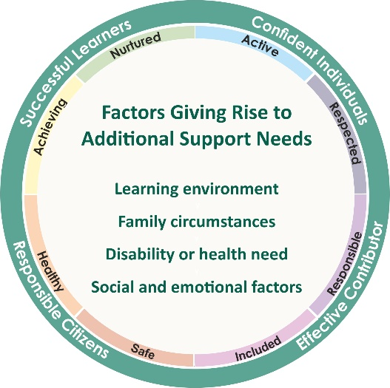

Reducing barriers and supporting needs
Effective communication between professionals, parents/carers and learners is an essential contributing element required to reduce any barriers to learning. A child or young person may have additional support needs arising from more than one of the factors highlighted in the image above Additional support for children and young people may be provided in a range of locations including in school, at home, in hospital, or in a specialist health, social services or voluntary agency facility.

Who identifies Dyslexia?
Everyone has the skills and abilities to recognise early signs of dyslexia in children at all stages and take appropriate action in response. Pupil support begins with the class teacher, but this does not mean that class teachers are responsible for the formal identification of dyslexia. It means that they play an important role in the initial stages and the continuing monitoring and assessment of learning – as they do for all their pupils. If the concerns continue despite the intervention and support provided, pupil support teachers/support for learning teachers or school management would begin to link in with a range of colleagues and the family as appropriate.

Pupil support begins within the classroom and initially the class teacher or early years practitioner takes responsibility for recognising the possible signs of literacy difficulties and dyslexia and then using the Addressing Dyslexia
Toolkit to begin the process and start to identify and support the specific nature of the difficulties the child is having.

A range of professionals may be involved in the identification process and working together collaboratively will support the identification and the needs of the child/young person. The role and views of the parents, carers, child or young person is very important. Parents, carers or someone else involved with the family (e.g. social worker, health visitor) may have brought concerns to the teacher's notice in the first instance.
Role of class teacher and school

Further information is available on the Toolkit http://addressingdyslexia.org/roles-and-partnership-working

Enquiry and Research
Reading approaches
Literacy and Dyslexia
How do we know dyslexia exists?

Further research and literature review
Appropriate teaching Approaches

How do we know dyslexia exists?
Advances in medical science have enabled the identification of Dyslexia to be understood in greater detail. Neuroscience research through brain imaging has identified diversity in the brain for adolescents and for those with dyslexia. Due to the body of research undertaken over the past few decades by a range of academic and medical researchers there is an acceptance that when identified appropriately dyslexia is a recognised learning difference and is the result of a neurological difference and is not a reflection on a learner’s level of intelligence or cognitive ability. The impact of dyslexia as a barrier to learning varies in degree according to the learning and teaching environment.
Dyslexia can be defined as neuro-developmental in nature, with a biological origin and behavioural signs which extend far beyond problems with written language. Uta Frith. Chapter 3: Dyslexia and Litercay: Theory and Practice. Edited by Gavin Reid and Janice Wearmouth. 2002. John Wiley & Sons, Ltd
In 1999 the American Journal of Neuroradiology, provided evidence that dyslexia is neurological in nature. The interdisciplinary team of University of Washington researchers also showed that dyslexic children use nearly five times the brain area as normal children while performing a simple language task.
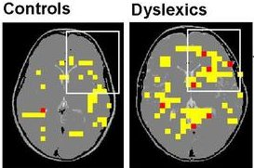
Although the mages above were taken in 1999 they highlight very clearly the differences between areas of the brain which are activated while performing simple language tasks in yellow. Red indicates areas activated in two or more children. Pic: Todd Richards, University of Washington
"The dyslexics were using 4.6 times as much area of the brain to do the same language task as the controls," said Todd Richards, co-leader of the study. "This means their brains were working a lot harder and using more energy than the normal children". "People often don't see how hard it is for dyslexic children to do a task that others do so effortlessly," added Virginia Berninger, a professor of educational psychology. http://www.abc.net.au/science/articles/1999/10/05/57074.htm
Morton & Frith, 1993; 1995 developed a neutral framework for the causal modelling of developmental disorders and applied this modelling to dyslexia. The research highlights that Dyslexia can be split into 3 main research areas, all of which inter- link and influence one another.

- Neurological - Brain structure and genetic factors
- Cognitive - How people learn
- Behavioural - How people behave and their reactions to this learning difference
These are influenced by Environmental factors both at home and school.

Environmental factors influencing home and nursery/school
Behavioural – How people behave, their reactions and understanding of dyslexia
How behaviour is affected through appropriate or lack of appropriate support, understanding and ethos
Cognitive – How people learn
Neurological – Brain structure and genetic factors
Literacy and Dyslexia

Dyslexia, Literacy
Dyslexia is intricately linked, however as the Scottish working definition highlights, dyslexia is not only about experiencing literacy difficulties and literacy and should not be viewed in isolation.

All areas of literacy can have an impact on how children and young people access the wider curriculum. It is recognised that good teaching and learning approaches which support children and young people with dyslexia also support those who experience literacy difficulties.

What is literacy?
In defining literacy for the 21st century we must consider the changing forms of language which our children and young people will experience and use. Accordingly, our definition takes account of factors such as the speed with which information is shared and the ways in which it is shared. The breadth of our definition is intended to ‘future proof’ it

“Our ability to use language is central to our thinking, our learning and our personal development. Literacy and language unlock access to the wider curriculum and lay the foundations for communication, lifelong learning and work, contributing strongly to the development of all four capacities of Curriculum for Excellence”.
3-18 Literacy and English Review.

National Resources and Guidance to Support Literacy Strategies

National Literacy Professional Learning Community on GLOW
Please note a GLOW login is required to access this site.
The purpose of this professional learning community is to provide:
professional learning resources and links to relevant research
quick links to the most up-to-date literacy and English documents and information
a range of support materials and resources for learning, teaching and assessment in literacy and English across the curriculum

National School Libraries Professional Learning Community on GLOW
Please note a GLOW login is required to access this site.
Education Scotland's National School Libraries PLC, a virtual learning environment for all those involved in school library provision in Scotland. The purpose of this professional learning community is to provide:
the most up-to-date documents and national programmes
professional learning opportunities, digital learning resources and links to relevant research
links to key organisations and partnership working opportunities
Early literacy approaches required for learning can be applied to any learners with literacy difficulties. Using resources such as the Addressing Dyslexia Toolkit with links to enquiry and research e.g. Education Scotland, will enable classroom practitioners to identify the language development needs of all young people
Language Development

What happens to children in their earliest years is key to outcomes, including the improvement of educational attainment in childhood, adolescence and in adult life. There is a strong relationship between early life experiences and how children learn. The importance of positive influences in the early years will improve a child's life chances. These early learning experiences are vital in forming the building blocks from which more formal literacy learning can be developed. A literacy rich environment
- significantly increases language comprehension and expression when listening to stories read aloud, either at home or at school.
- promotes, supports and enriches listening, talking, reading and writing
- models high standards and sets high expectations for literacy

In the very early years the home learning environment for children from birth to 3 years old has a significant impact on cognitive and language development. Parents, irrespective of socio-economic group or where they live, can make a real difference to their children's outcomes by talking to them, playing with them and ensuring they engage in different experiences
http://www.gov.scot/Publications/2010/10/27084039/5

As children grow towards primary school age, their social, emotional, physical and education wellbeing build upon foundations laid in earlier years and continue to be influenced by their home environment and their relationship with their parents. Before formal education can begin, a range of skills should ideally be learnt by the children. Consider what you think these are and click the ‘reveal button’ for the answer.
Before formal education can begins children must learn to:
- play
- talk
- listen
- understand
- attend
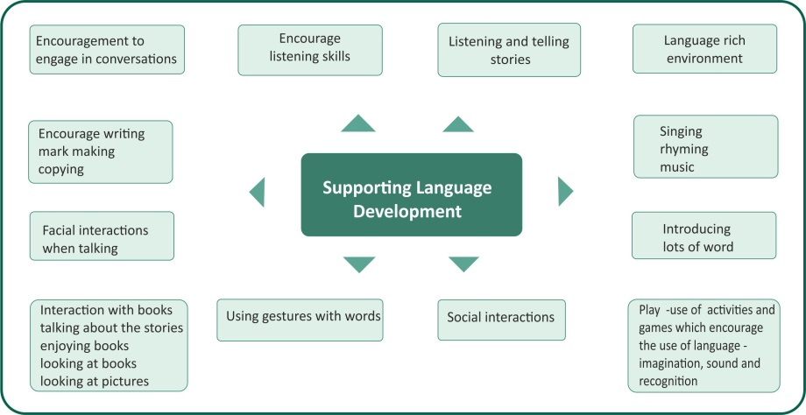

The image on the previous page highlights helpful approaches which can support good language development in young children. A range of resources have been developed by Allied Health Profession for example speech and language therapists to highlight the expected language developmental milestones.

To support the development of language and numeracy skills for children in Primary 1 – 3 the Scottish Government is leading a campaign which focuses on key skills among children called Read, Write and Count. It is aimed at encouraging and supporting parents and families who have a key role to play in helping their children to read, write and count well, by incorporating these into their everyday activities, such as walking around the supermarket or travelling home from school.

The campaign builds on the Scottish Government’s PlayTalkRead early years campaign and is being delivered in partnership with Education Scotland and The Scottish Book Trust over 3 years. It builds on relevant established frameworks which include Curriculum for Excellence and Raising Attainment for All and aims to tackle educational inequalities and raise attainment in early years and beyond.
For more information and resources on Read, Write, Count, visit www.readwritecount.scot.

listening activities and/or games to help them develop phonological awareness. This can be true of learners of any age.

Listening Skills
Listening skills develop from infancy and can be encouraged with activities incorporating sounds, songs, repetition and stories. A planned approach to developing listening and talking skills in the early years will lay the foundations for reading and writing as well as developing social and communication skills. Children significantly increase their language comprehension and expression when listening to stories read aloud, either at home or at school.

Listening and phonological awareness skills linked and these are important in order to develop good reading skills. Having good phonological awareness skills means that a child is able to manipulate sounds and words, or “play” with sounds and words. For example, a teacher or speech-language pathologist might ask a child to break the word “cat” into individual sounds: “c-a-t” if learners are finding it difficult to identify and isolate sounds they HEAR in a word. Continuous tracking of their progress though the stages is vital to ensure solid foundations to build the skills of reading and writing.

A range of free resources available on the Addressing Dyslexia Toolkit
http://addressingdyslexia.org/free-resources-support-collaborative-assessments
- Phonological Awareness
- Alphabet Awareness
- Manipulation of letters, sounds and words

Talking Skills
Planning, organising and saying what we want to say involves many different skills. Talking skills develop form infancy activities incorporating sounds, songs, repetition and stories. Talking skills develop from infancy and can be encouraged with activities incorporating sounds, songs, repetition and stories. A planned approach to developing listening and talking skills in the early years will lay the foundations for reading and writing as well as developing social and communication skills.
http://www.educationscotland.gov.uk/learningandteaching/assessment/ssln/resources/literacydiscussionnew/index.asp

Children need to develop an understanding of using the right words in the right order to express themselves clearly. They also require exposure to a rich language environment in early years to develop a wide range of vocabulary to enable them to communicate effectively and achieve positive outcomes.

Reading Skills

If learners are encouraged and supported to read a wide range of texts for enjoyment, they will become more confident in making independent choices in their reading material. Developing as a reader is linked to positive attitudes and experiences as well as skills. CfE recognises the fundamental importance of reading for enjoyment within the reading experiences and outcomes.

If the sound cannot be matched to a letter, the successful introduction of phonics is compromised. Struggling readers of all ages may benefit from revisiting early skills and breaking them down. A range of support approaches and strategies are available for teachers to help children develop their reading skills.

Writing Skills

Writing skills – mark making begins in a child’s early years an s should be supported and encouraged. If learners are to become successful and confident writers, then writing has to be viewed as an essential part of the learning environment and across curriculum areas. Learners should have regular opportunities to write to develop and demonstrate knowledge and understanding and to make sense of their learning.

They should experience an environment which is rich in language and which sets high expectations for literacy and the use of language It is important writing tasks are engaging and relevant with an explicit focus on the skills and knowledge being developed. Writing skills are dependent on reading skills and should be taught alongside each other.

Reading and Writing Circles
http://addressingdyslexia.org/identification-formstemplates

The literacy circles have been developed by the Toolkit to provide a detailed view and understanding of how a child or young person’s literacy skills have developed. They can be used in primary and secondary sectors and may also be beneficial for children and young people for whom English is not their first language, as well as for adults. The circles provide:
- Descriptions of the key areas involved in the acquisition of reading skills
- A tool to identify areas of difficulty
- Approaches and strategies for each key area
- A practical resource sheet/evaluation tool to record discussion, highlight strengths, difficulties and to plan the next steps appropriately.

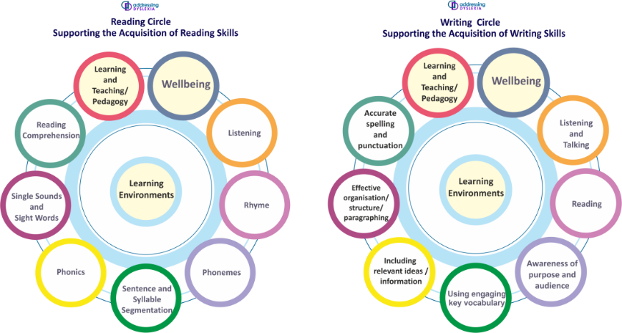

Learning English as an Additional Language and Dyslexia.
Speakers of any language can have dyslexic difficulties, but these may be different in the ways they manifest themselves. It will be more obvious in some languages than others depending on the spelling rules and writing structures.

For children who speak languages other than English at home, the assessment process will require very careful consideration. Consideration will require to be given to the child’s first language as well as English, and this may require assistance from a professional who shares the same language as the child.
It must be remembered that the phonology of the child’s first language is likely to be different from English, and scripts too may be different. As an example, Polish children who have wholly developed literacy skills will have experience of decoding in alphabetic script but in the case of children exposed to logographic scripts, the relationship between sounds and symbols will be markedly different. Even although children may not have learned to read in their first language they will have been exposed to environmental print. The issue for teachers is to consider whether the children’s difficulties with language extend beyond them having English as another language.

Avoid using standardised assessments, particularly with those new to English as the English and cultural content may give false information. It is more useful to build a profile of the learner’s strengths, including what they can do in their first language as well as information about their educational background.
To support EAL learners with possible dyslexia focus on support for the first language involving parents. Many of the strategies that support dyslexic learners will work well with EAL learners but in addition it is important to focus on building vocabulary in a meaningful context, taking account of cultural factors.
Tony Cline
Deryn Hall: Assessing the Needs of Bilingual Pupils, Fulton, London 1995

Research (Ganschow and Sparks, 2000) confirms that strengths and weaknesses in the linguistic codes of
phonology/orthography (sounds/letter patterns), syntax and semantics are transferred between languages. So learning a second language challenges dyslexic students because it requires those skills that are frequently compromised in dyslexia - sequencing ability, phonological knowledge and both short and long-term memory (Wolf, 2008). The processing differences associated with SpLD/dyslexia can also cause listening difficulties (Crombie & McColl, 2001) making a second language as complex, inconsistent and challenging as English, more difficult for dyslexic children to acquire (Ziegler et al, 2003).

DysTEFL (Dyslexia for Teachers of English as a foreign Language)

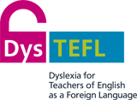

Languages without Limits
Teachers of foreign languages will find a range of useful information to help with language learning and inclusion in the foreign language classroom
Reading approaches

If learners are encouraged and supported to read a wide range of texts for enjoyment, they will become more confident in making independent choices in their reading material. Developing as a reader is linked to positive attitudes and experiences as well as skills.
CfE recognises the fundamental importance of reading for enjoyment within the reading experiences and outcomes.

Over the years there has been professional debate and dialogue over the most effective and appropriate methods for teachers to use when developing reading skills in children.
Top down theory
The top down approach to reading emphasises that reading is a meaning driven process, where the reader uses meaning predictions to read. When meaning is lost the student focuses more intently on the visual information to process the print.

Bottom up theory
The bottom up approach to reading emphasises that reading is taught through students first learning the alphabetic principle (grapho-phonic – the rules of sound and symbol relationships). Meaning takes place after accurate decoding of print.

Turbill, (2002) suggests constant discussion of these theories drives teachers to search for better ways in creating a balanced pedagogy of reading for all children.
http://www.decd.sa.gov.au/literacy/files/pages/Programs%20and%20Resources/DECS_Reading_in_the_early.pdf

Children who experience difficulties with the acquisition of literacy skills will require a range of approaches to support their reading skills. For example, a child who has auditory processing difficulty or has glue ear will find it very hard to hear the phonological sounds and transfer them to the graphic images of text. If this is the only approach used in their class, they may experience additional barriers to their literacy development.

Literature Reviews and Further Research

2008 Dyslexia Review Literature Review
http://www.educationscotland.gov.uk/Images/lrcapecd_tcm4-712884.pdf

2014 Dyslexia Review - Education Scotland Review Making Sense Dyslexia: Education for Children and Young People with Dyslexia in Scotland.

2015 CLPL Route Map for Dyslexia and Inclusion Literature review
Analytical Services Team, April 2015

1. Introduction
This paper highlights a definition of dyslexia, some key resources and summarises the latest research on dyslexia published since 2010. Although there is a vast amount of research available which focuses on dyslexia, there has been little in the last five years which has advanced the understanding of the learning difficulty any further.

2. Definition of dyslexia
In January 2009, the Scottish Government, Dyslexia Scotland and the Cross Party Group on Dyslexia in the Scottish Parliament agreed on the following working definition of dyslexia. The aim of this particular definition is to provide a description of the range of indicators and characteristics of dyslexia as helpful guidance for educational practitioners, learners, parents/carers and others.

Dyslexia can be described as a continuum of difficulties in learning to read, write and/or spell, which persist despite the provision of appropriate learning opportunities. These difficulties often do not reflect an individual's cognitive abilities and may not be typical of performance in other areas. The impact of dyslexia as a barrier to learning varies in degree according to the learning and teaching environment, as there are often associated difficulties such as:
- auditory and /or visual processing of language-based information
- phonological awareness , oral language skills and reading fluency
- short-term and working memory
- sequencing and directionality
- number skills
- organisational ability
Motor skills and co-ordination may also be affected.

Dyslexia exists in all cultures and socio-economic backgrounds. It is a hereditary, life-long, neurodevelopmental condition. Unidentified, dyslexia is likely to result in low self-esteem, high stress, atypical behaviour and low achievement. Learners with dyslexia will benefit from early identification, appropriate intervention and targeted effective teaching, enabling them to become successful learners, confident individuals, effective contributors and responsible citizens.

From a review of the information available on dyslexia, there is already a wealth of Scottish literature which provides information about definitions, associated difficulties, underlying causes and advice on assessment and intervention. These include:

- Addressing Dyslexia Toolkit (2012): This was originally launched as the Assessing Dyslexia Toolkit for Teachers in June 2010, and outlines the definition of dyslexia that has been developed by the Scottish Government, Dyslexia Scotland and the Cross Party Group on Dyslexia.

- Supporting Pupils with Dyslexia at Primary School (2011): A series of 8 booklets that were provided to every primary school in Scotland and contain information and advice about dyslexia from the early stages to transition to secondary school, and also contain information for support for learning departments, school management teams, as well as about good practice when working with parents. These booklets can be downloaded from the Dyslexia Scotland website

- Supporting Pupils with Dyslexia in the Secondary Curriculum (2013): A series of 20 booklets that were provided to every secondary school in Scotland and aim to provide subject teachers and support staff with advice and strategies to support learners with dyslexia. The booklets can be downloaded from the Dyslexia Scotland website

- Dyslexia at Transition (2007) – The Dyslexia at Transition Project Team consisted of staff from Edinburgh, Strathclyde and Aberdeen Universities and education authorities. The team worked with school staff, parents and pupils to produce a DVD and support pack ‘Dyslexia at Transition’. The DVD, commissioned by the (then) Scottish Executive. The resource was launched in 2007 and provides examples of best practice to help schools to support the move of pupils with dyslexia from primary to secondary school.

3. Research summaries
Assessment of dyslexia and intervention
Berninger, V. W., Lee, Y-L, Abbot, R. D. and Breznitz, Z. 2013. Teaching children with dyslexia in reading -Writers workshop. Annals of Dyslexia, 63, p.1-24.
This research looked at spelling and word decoding problems in dyslexia, and what treatments may be effective in addressing them. Twenty-four primary age children (9-14 years old) were assigned to a one-hour reading-writers workshop at a university. Most of the participants were boys, which is consistent with research showing that males with dyslexia are more likely than girls with dyslexia to have writing problems and that gender differences are more likely in writing than reading skills (Berninger, Nielsen, Abbott, Wijsman & Raskind, 2008). The intervention was found to significantly improve reading and writing. The authors concluded that using orthographic strategies with working memory in mind could help students with dyslexia with spelling and reading. Some limitations to this research are the small sample size and the highly technical language used to describe the intervention and methodology.

Welsh Government (2012). Research into Dyslexia Provision. Cardiff: Welsh Government. Link
A literature review commissioned by the Welsh Government which explores research into dyslexia. The review provides definitions of dyslexia, overlapping disorders, assessment of dyslexia and provides examples of best practice interventions.

Reid, G., Strnadova, I. and Cumming, T. 2013. Expanding horizons for students with dyslexia in the 21st century: universal design and mobile technology. Journal of Research in Special Educational Needs, 13 (3), p.175-181.

This paper discussed the role of mobile technology in supporting people with dyslexia in areas such as reading, composing text, note-taking, organisation, metacognition and study skills. No actual empirical research is reported, though programmes, apps and software applications to support each area are described. This paper also cites the Scottish assessment process for dyslexia (in 2011) as an example of good practice. - http://www.addressingdyslexia.org/pages/index.php?category=11

Snowling,M.J. 2013.Early identification and interventions for dyslexia: a contemporary view, Journal of Research in Special Educational Needs, 13 (1), p.7-14

Reviews current proposals concerning the definition of dyslexia and contrasts it with reading comprehension impairment. Discusses methods for early identification and considers evidence that teacher assessments and ratings may be valid screening tools. Suggests that interventions should be theoretically motivated and evidence based. Notes that the early identification of children at risk of dyslexia, followed by the implementation of intervention, is a realistic aim for practitioners and policy-makers.

Bell,McPhillips and Doveston, M. 2011. How do teachers in Ireland and England conceptualise dyslexia? Journal of Research in Reading, 34 (2), p.171-192: A comparative study which used data from questionnaire surveys in England and Ireland to ascertain how teachers and teaching assistants described dyslexia and how this might influence their teaching. A total of 72 postal questionnaires were returned and the data was investigated using a thematic analysis. The findings highlighted a distinct Anglo-Irish contrast in conceptualisations of dyslexia, but also some common themes, e.g. the use of a discrepancy model of dyslexia. The researchers cautioned that using such a model may risk missing other important variables, such as the learning environment at the teacher, classroom, whole school and the community level. The paper also suggested that teachers need a clearer understanding of the relationship between the pupil’s individual profile, the task and the environment. Another interesting finding was that many dyslexic pupils were reported to be receiving some form of individual or small group tuition. Some research has shown that individual tuition is not always an essential component (Brooks, 2007; Rose, 2009; Torgesen, 2002) and that a blend of small group instruction and one to one teaching can be equally effective.

Mortimore.T, Hansen.L, Hutchings .M, Northcote.A, Fernando .J, Horobin .L, Saunders.K, Everatt.J. 2012. Dyslexia and Multilingualism: Identifying and supporting bilingual learners who might be at risk of developing SpLD/dyslexia.
http://www.bdadyslexia.org.uk/common/ckeditor/filemanager/userfiles/About_Us/Projects/Big_Lottery_Research_Report_Final_Version.pdf
This research focus on Dyslexia and English as an additional language.

Impact on learning
Casserly A.M. 2013. The Socio-Emotional Needs of Children with Dyslexia in Different Educational Settings in Ireland, Journal of Research in Special Educational Needs, 13 (1), p.79-91.
A paper which reports on a four-year research project examining the experiences of children with dyslexia in mainstream schools and reading schools/classes. The focus of this paper is on the socio-emotional effects of dyslexia on a group of children attending a reading school/class for a specific duration before returning to mainstream. The findings suggest that while the primary focus of attending such a placement is to attain greater levels of literacy, other gains such as increased positive socio-emotional manifestations and confidence are also evident. Therefore, the emotional elements of learning must work in tandem with the academic elements in helping children with dyslexia access the curriculum in full. The roles of attribution, motivational and expectancy theories are explored and how a comprehensive understanding of these theories can help teachers explain and respond to the exhibited behaviours of children with reading difficulties.
Driver Youth Trust (2013). The Fish in the Tree: Why We Are Failing Children With Dyslexia. Richmond-Upon-Thames: Driver Youth Trust. Link
A report by an England-based charity which discusses research carried out with young people with dyslexia. It discusses what dyslexia is, the achievement gap between those with learning difficulties such as dyslexia and their peers, the economic and social costs, and highlights issues in relation to teacher training. The research indicated that many teachers felt they were not receiving the necessary training and support to teach young people with dyslexia.
Gibson, S. and Kendall, L. (2010). Stories From School: Dyslexia and Learners’ Voices on Factors Impacting on Achievement. Support for Learning, 25 (4), pp. 187-193.
A report which presents research commissioned by the Higher Education Academy carried out by academics in two universities in England. The research explored the transition to higher education for students with identified disabilities such as dyslexia. Looks back at the students’ school experiences, particularly factors which impacted on their self-esteem and academic achievement.

Wennås Brante, E. (2013). ‘I Don’t Know What It Is to Be Able to Read’: How Students with Dyslexia Experience Their Reading Impairment. Support for Learning, 28 (2), pp 79-85.
Better understanding of the diverse reading abilities of people with dyslexia is necessary for the design of more effective learning situations, which are vital both to students with dyslexia and to their teachers. Seven individuals with dyslexia currently or formerly in higher education were interviewed about their reading experiences to learn how they themselves understand and describe their reading. The interviews are treated as individual profiles. Although the respondents were adult experienced readers, aware of their impairments, none could identify any strategy for overcoming dyslexia other than investing much time in homework and study. Each profile is unique, yet they share some characteristics, including strong parental support and a refusal to accept the label of "stupid". Teachers need to recognise the diverse effects of dyslexia in order to improve the chances of dyslexic students - especially those who cannot rely upon strong parental support - of continuing to higher education.
Glazzard, J. (2010). The Impact of Dyslexia on Pupils’ Self-Esteem, Support for Learning, 25 (2), pp. 63-69.
A report which presents the findings of a small-scale study which explored the factors that affect the self-esteem of learners with dyslexia. The study involved interviews with nine secondary school pupils who had been diagnosed with dyslexia in two mainstream schools in the north of England. It found that comparisons with other students and the attitudes of teachers, peers and family members can have a significant impact on the self-esteem of students with dyslexia. However, the research indicated that an early diagnosis of dyslexia can have a major impact in terms of creating a positive self-image. After students were diagnosed their confidence increased and they were able to distinguish between their specific difficulties and the idea of intelligence.
Nalavany, B. A., Carawan, L. W. and Brown, L. J. 2011. Considering the role of traditional and specialist schools: do school experiences impact the emotional well-being and self-esteem of adults with dyslexia. British Journal of Special Education, 38 (4), p.191-200.
Research considering how different educational settings may impact adulthood as empirical literature suggests that children, adolescents and adults with dyslexia are at increased risk of low self-esteem. The researchers systematically reviewed the literature about how specialist and mainstream school settings impact on the social-emotional well-being of adults with dyslexia. Two themes emerged; feelings of ostracism and stigma; and a host of different emotions including feelings of disappointment, frustration, embarrassment, shame, depression and low-self-esteem. The current research surveyed 224 adults with dyslexia online to identify the experiences that facilitated or hindered them. About half had attended a specialist school and half a mainstream school. Their analysis suggested that adults who attended specialist schools were significantly less likely to be clinically diagnosed with anxiety or depression. They offered some reasons as to why this may be the case, for example, a focus on the development of coping strategies in specialist settings; and the presence of peers with similar difficulties as a source of emotional support in specialist settings. The authors state that the school context may serve as either a protective or risk factor in association with dyslexia and self-esteem. However, there are some limitations to this study. Firstly, the sample was self-selected so there may be inherent sampling bias, as the researchers were unable to determine if the sample was representative of the general population of adults with dyslexia. Also a large majority of the respondents went to the same specialist school and it may this school in particular that made a difference. Lastly, all the data can show is that there is a positive difference between adults who attended different school settings; whether the specialist school directly influenced self-esteem or served as a protective factor in itself, can only be inferred and not attributed to causality.

Dyslexia and neuroscience
Research marked with * denote those articles where the abstract has been summarised.
*Temple, E., Poldrack, R. A., Salidis, J., Deutsch, G. K., Tallal, P., Merzenich, M. M., and Gabrieli, J. D. E. 2001. Disrupted neural responses to phonological and orthographic processing in dyslexic children: an fMRI study. Neuroreport, 12 (2), p.299-307.
Developmental dyslexia, characterized by difficulty in reading, has been associated with phonological and orthographic processing deficits. Functional Magnetic Resonance Imaging (fMRI) was performed on dyslexic and normal-reading children (8–12 years old) during phonological and orthographic tasks of rhyming and matching visually presented letter pairs. During letter rhyming, both normal and dyslexic reading children had activity in left frontal brain regions, whereas only normal-reading children had activity in left temporo-parietal cortex. During letter matching, normal-reading children showed activity throughout extrastriate cortex, especially in occipito-parietal regions, whereas dyslexic children had little activity in extrastriate cortex during this task. These results indicate dyslexia may be characterized in childhood by disruptions in the neural bases of both phonological and orthographic processes important for reading.
*Guinevere, F. E. and Moats, L. 2002. The role of neuroscience in the remediation of students with dyslexia. Nature Neuroscience Supplement, 5 (11), p.1080-1084.
Dyslexia is a specific learning disability that is neurobiological in origin. It is characterized by difficulties with accurate and/or fluent word recognition, spelling and decoding abilities. Research findings agree that these and other observed behavioral manifestations largely result from a deficit in the phonological component of language. However, conflicting theories on the exact nature of the phonological deficit have given rise to divergent treatment approaches. Recent advances in functional brain imaging and genetics have allowed these theories to be examined more closely. If implemented appropriately, commercial programs can be effective in identifying dyslexia. Treatment of dyslexia has been advanced through neuroscience, yet further study is needed to provide rigorous, reproducible findings that will sustain commercial approaches.
*Katzir, T. & Pare-Blagoev, J. 2010. Applying Cognitive Neuroscience Research to Education: The Case of Literacy. Educational Psychologist, 41 (1), p.53-74.
Neuroscience has provided fascinating glimpses into the brain's development and function. Despite remarkable progress, brain research has not yet been successfully brought to bear in many fields of educational psychology. In this article, work on literacy serves as a test case for an examination of potential future bridges linking mind, brain, and educational psychology. This article proposes a model for integrating research in the cognitive neurosciences with educational psychology and reviews how neuroscience is providing new data relevant to 3 major controversies in the field of dyslexia. This article also discusses the relevance of these findings for psycho-educational assessment and instruction and suggests innovative venues for interdisciplinary research.
*Rubenstein, K., Matsushita, M., Berninger, V. W., Raskind, W. H. and Wijsman, E. M. 2011. Genome scan for spelling deficits: effects of verbal IQ on models of transmission and trait gene localization. Behavior Genetics, 41 (1), p.31-42.
Dyslexia is a complex learning disability with evidence for a genetic basis. Strategies that may be useful for dissecting its genetic basis include the study of component phenotypes, which may simplify the underlying genetic complexity, and use of an analytic approach that accounts for the multi-locus nature of the trait to guide the investigation and increase power to detect individual loci. Here we present results of a genetic analysis of spelling disability as a component phenotype. Spelling disability is informative in analysis of extended pedigrees because it persists into adulthood. We show that a small number of hypothesized loci are sufficient to explain the inheritance of the trait in our sample, and that each of these loci maps to one of four genomic regions. Individual trait models and locations are a function of whether a verbal IQ adjustment is included, suggesting mediation through both IQ-related and unrelated pathways.
*Blomert, L. and Willems G. 2010. Is there a causal link from a phonological awareness deficit to reading failure in children at familial risk for dyslexia? Dyslexia, 16 (4), p.300-317.
This research investigated children at familial risk for dyslexia in kindergarten and first grade. The familial risk saw 40% of the children developing reading deficits in first grade. Unlike previous research, the authors did not find any relationship between a phonological awareness or other phonological processing deficits in kindergarten and reading deficits in first grade. Also they did not find evidence for the claim that a phonological awareness deficit causes a reading deficit via 'unstable' or otherwise corrupted letter-speech sound associations. Although earlier research indicated letter knowledge as another significant determinant of later reading deficits, they found no support for this claim. The authors concluded that letter knowledge learning and learning to associate and integrate letters and speech sound are different processes and only problems in the latter process seem directly linked to the development of a reading deficit.
*Waldie, K. E., Haigh, C.E., Badzakova-Trajkov, G, Buckley, J. and Kirk, I.J. 2013. Reading the wrong way with the right hemisphere. Brain Sciences, 3, p.1060-1075.
Reading is a complex process drawing on a variety of brain functions in order to link symbols to words and concepts. The three major brain areas linked to reading and phonological analysis include the left temporoparietal region, the left occipitotemporal region and the inferior frontal gyrus. Decreased activation of the left posterior language system in dyslexia is well documented but there is relatively limited attention given to the role of the right hemisphere. The current study investigated differences in right and left hemisphere activation between individuals with dyslexia and non-impaired readers in lexical decision tasks (regular words, irregular words, pseudowords) during functional Magnetic Resonance Imaging (fMRI). Results revealed the expected hypo-activation in the left posterior areas in those with dyslexia but also areas of over-activation in the right hemisphere. During pseudoword decisions, for example, adults with dyslexia showed more right inferior occipital gyrus activation than controls. In general the increased activation of left-hemisphere language areas found in response to both regular and pseudowords was absent in dyslexics. Laterality indices showed that while control participants showed left lateralised activation of the temporal lobe during lexical decision making, dyslexic readers showed right activation. The researchers concluded that these findings could inform theories of reading and have implications for the design of reading interventions.
*Bishop, D. V. M. 2013. Research review: Emanuel Miller Memorial Lecture 2012 - Neuroscientific studies of intervention for language impairment in children: interpretive and methodological problems. Journal of Child Psychology and Psychiatry, 54 (3), 247-259.
Many studies of developmental disorders now routinely include a brain imaging or electrophysiological component. Amid current enthusiasm for applications of neuroscience to educational interventions, the authors suggest that researchers need to pause to consider what neuroimaging data can tell us. They state that images of brain activity are seductive, and have been used to give credibility to commercial interventions, yet we have only a limited idea of what the brain bases of language disorders are, let alone how to alter them. The authors reviewed six studies of neuroimaging correlates of language intervention and found recurring methodological problems including: lack of an adequate control group; inadequate power; incomplete reporting of data; no correction for multiple comparisons; and failure to analyse treatment effects appropriately. In addition, there is a tendency to regard neuroimaging data as more meaningful than behavioural data, even though it is behaviour that interventions aim to alter. The authors concluded that in our current state of knowledge, it would be better to spend research funds doing well-designed trials of behavioural treatment to establish which methods are effective, rather than rushing headlong into functional imaging studies of unproven treatments.
*Stoodley, C. J. and Stein, J. F. 2013. Cerebellar function in developmental dyslexia. The Cerebellum, 12 (2), p.267-276.
Developmental dyslexia is a genetically based neurobiological difficulty. As well as reading, writing and spelling, some dyslexics also have impairments in attention, short-term memory, sequencing, eye movements and balance. Functional imaging studies suggest that the cerebellum is part of the neural network supporting reading in typically developing readers, and reading difficulties have been reported in patients with cerebellar damage. Differences in both cerebellar asymmetry and gray matter volume are some of the most consistent structural brain findings in dyslexics compared with non-dyslexic readers. However, many dyslexics do not have cerebellar signs, and many cerebellar patients do not have reading problems. Therefore, the authors conclude that impaired cerebellar function is probably not the primary cause of dyslexia, but rather a more fundamental neurodevelopmental abnormality which leads to differences throughout the reading network.
*Black, J. M. et al. 2012. Maternal history of reading difficulty is associated with reduced language-related gray matter in beginning readers. Neuroimage, 59 (3), p.3021-3032.
Family history and poor pre-literacy skills (referred to here as familial and behavioural risk, respectively) are critical predictors of dyslexia. This study systematically investigated the independent contribution of familial and behavioural risks on brain structures, which had not been explored in past studies. The research involved assessing 51 children (5 to 6 years of age) with varying degrees of familial and behavioural risks for developmental dyslexia. They found that greater maternal history of reading disability was associated with smaller bilateral prefrontal and parieto-temporal gray, but not white matter volumes. Taking into account behavioural risk, socioeconomic status, maternal education and other confounding variables did not change the results. No such relationship was observed for paternal reading history and behavioural risk. The results suggested greater maternal, possibly prenatal, influence on language-related brain structures. The authors concluded that these results may help to guide future neuroimaging research focusing on environmental and genetic influences and provide new information that may help predict which child will develop dyslexia in the future.
*Barquero, L. A., Davis, N. and Cutting, L. E. 2014. Neuroimaging of reading intervention : a systematic review and activation likelihood estimate meta-analysis. PloS One, 9 (1), e83668.
A growing number of studies examine instructional training and brain activity. The purpose of this paper is to review the literature regarding neuroimaging of reading intervention, with a particular focus on reading difficulties (RD). To locate relevant studies, searches of peer-reviewed literature were conducted using electronic databases to search for studies from the imaging modalities of fMRI and MEG that explored reading intervention. Of the 96 identified studies, 22 met the inclusion criteria for descriptive analysis. Findings from the literature review suggest differences in functional activation of numerous brain regions associated with reading intervention. Findings from the meta-analysis indicate change in functional activation following reading intervention in the left thalamus, right insula/inferior frontal, left inferior frontal, right posterior cingulate, and left middle occipital gyri. Though these findings should be interpreted with caution due to the small number of studies and the disparate methodologies used, this paper is an effort to synthesize across studies and to guide future exploration of neuroimaging and reading intervention.

Other suggested summaries
- Professor Julian(Joe) Elliot’s research should be included as he agrees there is a biologically based difference and his contention is the way it is identified and labelled. Research on e.g. phonological awareness and its impact on a learner’s ability to read is important.

- A commission by Save the Children (2013) by the National Literacy Trust http://www.literacytrust.org.uk/news/5638_poor_children_s_life_chances_determined_by_age_seven

- Further research on phonological awareness and its impact on a learner’s ability to read is important to give a balanced view

The following quotes have been lifted from, The Dyslexia Debate - Julian G. Elliott & Elena L. Grigorenko, Cambridge University Press, 2014

49 “Research into phonological deficits has resulted in the development of a range of related interventions for struggling readers that have shown to improve the skills and, consequently, reading performance”.

128 "Those with reading difficulties, irrespective of whether these are predominantly of biological or environmental origin, are more likely to be undermined by whole-language approaches that neglect explicit instruction of letter-sound relationships." (Various authors are cited; the latest Tunmer & Nicholson, 2011).

135 "The most powerful predictors [of reading proficiency or of response to intervention] proved to be phonological awareness and rapid naming of letters."

135 Difficulties with phonological awareness, rapid naming, vocabulary, and oral language skills are seen as the most common cognitive attributes of poor responders to intervention. (Fletcher et al., 2011)

Scottish Education - Legislative and Policy Framework Summary

Scotland has a wide range of legislation to support inclusion and equality in education.
These promote a child centred approach to encourage every child to reach their ‘fullest potential’. Our legislation ensures rights and entitlements for children and young people to education, support and wellbeing. There is a range of legislation and educational policies which place duties and expectations on schools and local authorities to ensure that they:

- Deliver an inclusive education
- Support learners to achieve to the best of their ability
- Do not discriminate against those with protected characteristics
- Provide assessments when requested

Children’s rights and entitlements are fundamental to Scotland’s approach to inclusive education. It is supported by the legislative framework and key policy drivers including, Curriculum for Excellence, the getting it right for every child approach and the Framework for Professional Standards for teachers. These are underpinned by a set of values aligned to social justice and commitment to inclusive education.

Updated Presumption of Mainstreaming Guidance
This guidance aims to bridge the gap between legislation, policy and day-to-day experience, ensuring that children and young people have equitable access to a quality education which meets their needs and helps them achieve their full potential.
https://consult.gov.scot/supporting-learners/presumption-of-mainstreaming/

Additional Support for Learning: Research on the experience of children and young people and those that support them
This qualitative research explored the experiences of children and young people of additional support for learning, and the experiences of those who support them.
https://www.gov.scot/publications/additional-support-learning-research-experience-children-young-people-those-support/
Education (Additional Support for Learning) (Scotland) Act 2004, amended 2009
This legislation provides a framework to support children and young people who require some help with their learning. The framework is based on the idea of additional support needs, a term which applies to any child or young person who requires additional support, long or short term, to help them make the most of their school education. The amended Act deems that all looked after children and young people have additional support needs unless the education authority has established through assessment that they do not. The Act also aims to ensure a partnership with parents/carers and collaborative working with professionals from partner services and agencies, to meet the needs of the child or young person. This module supports staff in meeting many of the learning needs of the learners in their school.
http://www.legislation.gov.uk/asp/2009/7/pdfs/asp_20090007_en.pdf

Supporting Children’s Learning: Code of Practice (Revised Edition) 2017
This provides guidance on the implementation of the Education (ASL) (Scotland) Act, as amended in 2009. It gives a summary of the Act including clear definitions of which groups of learners are covered by the Act and what constitutes additional support needs. The duties under the terms of the Act on education authorities and other agencies with respect to supporting children‘s and young people‘s learning are set out. Examples of best practice are provided with reference to the Getting it Right for Every Child (GIRFEC) approach and Curriculum for Excellence framework.
https://www.gov.scot/publications/supporting-childrens-learning-statutory-guidance-education-additional-support-learning-scotland/pages/1/

The Children and Young People (Scotland) Act 2014
This legislation underpins the Getting it Right for Every Child (GIRFEC) approach and aims to improve the way services work together to support children and young people. It provides a common practice framework and embeds partnership working with families across the full range of services and agencies in order to meet the needs and promote the wellbeing and potential of all children and young people. Key to this are a consistent single planning approach for children who require additional support from services, a Named Person for every child and a holistic understanding of wellbeing. In addition to the Named Person children who have complex needs may also have a Lead Professional to coordinate their care. In some cases, the Named Person will also take on the role of the Lead Professional, but this role could be taken on by any person who is closely involved with the child and their family, so could be from any agency. Under this legislation there are new duties placed on schools and other public bodies to focus on improving broader wellbeing outcomes for children.
http://www.legislation.gov.uk/asp/2014/8/pdfs/asp_20140008_en.pdf

The Equality Act 2010
This Act brings together and extends the existing UK equality legislation. The Act introduced protected characteristics (for example a person’s disability, race, ethnicity, religion and sexual orientation) for which discrimination is unlawful. The Act places specific duties on public bodies (including schools) and individuals to prevent discrimination, harassment and victimisation. In relation to schools this includes, for example, making reasonable adjustments to the school environment, teaching methods, assessment procedures and school trips to ensure that learners with protected characteristics (or learners associated with others who have these protected characteristics) are not discriminated against. Further guidance specifically for education providers, produced by the Equality and Human Rights Commission, can be accessed at
https://www.gov.uk/guidance/equality-act-2010-guidance
Curriculum for Excellence
The Curriculum for Excellence aims to improve the learning, attainment and achievement of children and young people. It clearly focuses classroom practice on the learner and around developing the four capacities of education: that young people should be successful learners, confident individuals, responsible citizens and effective contributors. This resource (Inclusive Learning and Collaborative Working: Ideas in Practice) aims to help teachers to meet these aspirations by providing supports and strategies which will promote the learning of all learners, by addressing specific areas of challenge and by giving information on how to seek out further support if required.
https://education.gov.scot/scottish-education-system/policy-for-scottish-education/policy-drivers/cfe-(building-from-the-statement-appendix-incl-btc1-5)/What%20is%20Curriculum%20for%20Excellence

How Good is Our School?
‘How Good is Our School?’ is designed to promote effective self-evaluation as the first important stage in a process of achieving self-improvement. It provides a framework for improvement that focuses in particular upon closing the gap in attainment, achievement and wellbeing between children and young people living in our most and least deprived areas in Scotland. ‘ Inclusive Learning and Collaborative Working: Ideas in Practice’ is designed to support self-evaluation for improvement.
For example, the supports and strategies detailed in each area of the Skills, Supports and Strategies section could act as a useful guide when evaluating how well the school makes arrangements to meet the learning needs of learners. The ‘discussion points’ included in most sections could also be used as a basis for discussions around self-evaluation; at both an individual and a whole school level.
https://education.gov.scot/improvement/Documents/Frameworks_SelfEvaluation/FRWK2_NIHeditHGIOS/FRWK2_HGIOS4.pdf
Scottish Schools (Parental Involvement) Act 2006
This legislation places duties on local authorities to support and strengthen the involvement of parents/carers in their children’s education. It refers to the body of evidence that supports the premise that children do better when parents/ carers and schools work together. The Act provides a framework which gives parents/carers the opportunity to get the information they need to support their child and encourages them to express their views and have these considered, either at individual meetings or through a school parent forum or parent council. Under the terms of the Act each local education authority must produce a ‘Strategy for Parental Involvement’ which will outline how parental engagement will be supported and strengthened
http://www.legislation.gov.uk/asp/2006/8/contents

Sustaining and Developing Professional Learning

A range of professional activities contribute towards professional learning and development for example:

- Professional reading and enquiry
- Meetings with colleagues
- Attending events
- Short courses including online learning
- Extended courses and award-bearing courses
- Accessing the Addressing Dyslexia Toolkit

A range of organisations are involved in providing CLPL support for educational practitioners

- Education Scotland
- Dyslexia Scotland
- Addressing Dyslexia Toolkit
- GTCS
- CALL Scotland
- Local Authorities
- Regional Improvement Collaboratives
- Universities

General Teaching council for Scotland (GTCS)

Professional update
The key purposes of Professional Update for teachers are:
- To maintain and improve the quality of our teachers as outlined in the relevant Professional Standards and to enhance the impact that they have on pupils' learning.
- To support, maintain and enhance teachers' continued professionalism and the reputation of the teaching profession in Scotland.

Professional Recognition
Professional Recognition is looking at expertise that moves beyond that expected of a teacher, for example moving from a grounded knowledge of assessment as set out in the Standard for Registration, to one where they have become an expert in this area, perhaps helping to support others.
http://www.gtcs.org.uk/professional-update/apply-for-professional-recognition-individual.aspx

pilot

Self-Evaluation

Framework for Inclusion

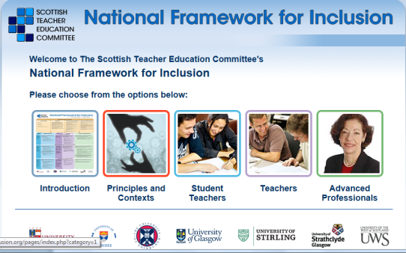
http://www.frameworkforinclusion.org/index.php

The Scottish Government, through the Scottish Teacher Education Committee (STEC), set up a Working Group to develop the Framework for Inclusion.
Who is the Framework for?
- Teacher educators designing ITE programmes
- Student teachers
- Teachers
- Teachers following advanced professional studies

What does the Framework include?

- values and beliefs for Inclusion
- professional knowledge and understanding for Inclusion
- skills and abilities for Inclusion

Dyslexia Scotland

Annual Dyslexia Scotland Education Conference

The Dyslexia Scotland Education Conference takes place every year in the autumn. This event is a useful professional learning opportunity for all teachers in building on their existing skills and experience and learning more about the practical aspects of supporting pupils with dyslexia. As well as excellent keynote speakers, the conference has a dynamic choice of practical workshops that are selected from the feedback from teachers who attended previous conferences. There is also the opportunity to visit a large marketplace, displaying the most recent materials and technologies to support teaching and learning for learners with dyslexia. Details at the following link: http://www.dyslexiascotland.org.uk/education-conference

Information leaflets on dyslexia can be accessed and freely downloaded–
http://www.dyslexiascotland.org.uk/links-and-resources

All state schools in Scotland were sent free copies of two series of booklets:
Supporting pupils with dyslexia in primary schools
Supporting pupils in the secondary curriculum

These are available free to download to Dyslexia Scotland members. Members also receive quarterly copies of “Dyslexia Voice” magazine to support CLPL and discounts on their annual Education conference. Details at the following link: http://www.dyslexiascotland.org.uk/why-join

Addressing Dyslexia Toolkit

Learning for Sustainability – equality and capacity building within the educational establishment/system

Local Authorities Examples of Building Capacity

Support Staff and Generic Approaches

Support Staff and Generic Approaches
It is important that all classroom practitioners involved in supporting learners have a similar approach. This is assisted by ensuring all support staff are given the same training across establishments and across education authorities. A common approach to e.g. Paired Reading, scribing for readers, overlearning activities and games would be of great benefit to learners who find it difficult to adapt to different methodology. It also gives support staff a greater confidence in their vital role within additional support for learning. For the same reasons, parents should also be encouraged to adopt a common approach to supporting their child at home.

Resources to support all teachers and help build capacity within schools

Primary One Literacy Assessment and Action Resource
http://www.educationscotland.gov.uk/resources/p/polaar/introduction.asp?strReferringChannel=educationscotland&strReferringPageID=tcm:4-615801-64

The Primary One Literacy Assessment and Action Resource (POLAAR) is designed to help P1 teachers identify and assess children who are most at risk of developing later difficulties with reading and writing.
It is based on a staged intervention model of ‘observe-action-observe’ which helps identify the most effective intervention to take at classroom and child levels.

It is designed for use by P1 teachers and others who support young children’s literacy learning and development.

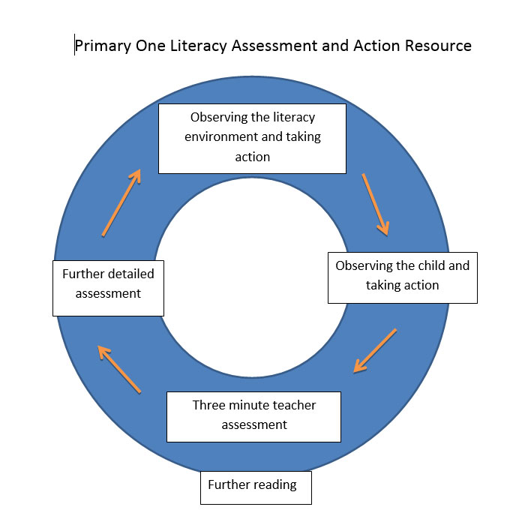
An illustration of the staged intervention model of ‘observe-action-observe’.

Local Authorities Examples of Building Capacity

Glasgow Dyslexia Support Service (GDSS)
- Phonological awareness programme – use timelines on Action Research paper, quotes from the action research and current update including city steering group (MG, Jane B) statement with Action Research paper, Stages of PA. Highlight the need for training of classroom practitioners before using materials. TRACKING

Inclusion Initiative
Establishments who request support from GDSS are introduced to a new initiative which uses the learning trail to provide a framework for developing capacity. Firstly, promoted members of staff with responsibility for ASN are introduced to similar colleagues from other establishments to form support groups. Using the Learning Trail as a tool to audit current practice and identify areas for improvement, they work with their own staff and a GDSS teacher to enhance the strategic development of literacy and dyslexia support within their school. Advice and training on assessment and intervention approaches are given to school staff in order to create a better understanding of diagnostic assessments and how to interpret them in order to inform and deliver next steps.

GDSS offer a variety of training units to Glasgow teachers in order to build capacity within establishments. Each training unit follows the support and development model in which participants learn about a key area of literacy based on current research. Participants engage in activities and are supported in how to deliver these in the practical setting of the classroom. Training units run over a period of 3-4 sessions allowing time for teachers to carry out allotted tasks and discuss findings with fellow attendees.

Edinburgh City Council
- Literacy and Dyslexia Programme- Hilary Aitken and Alison Mitchell Edinburgh to be consulted
- Education Scotland- Model for Change example of one of the speakers (Jan conference? )

Working In partnership – Local Authorities - Addressing Dyslexia Toolkit
Guidance for authorities is available via the link below with a view to establishing a common pathway for children and young people and consistency of approach across Scotland. Some samples of policies are also offered. It is recommended that in line with legislation, national policies and procedures, including this Toolkit, local authorities and independent schools will review and develop approaches and procedures for dyslexia when working with children, young people, families and staff. A pathway and examples of different policies are offered that local authorities and independent schools can follow.
http://www.addressingdyslexia.org/pages/index.php?category=32&sub=0

Summary Considerations

Insert text – Education Scotland?

