Addressing Dyslexia Toolkit - Professional Reflection and Planning Tool:  Supporting Learners and Families  This professional reflection and planning tool support opportunities to reflect on your knowledge and understanding of the areas highlighted within the Addressing Dyslexia toolkit and help you plan the next steps in your professional learning. |  |  |  |  |  |  | 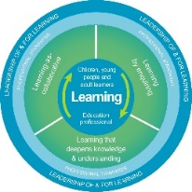
Name |  |  | Establishment |  |  | Date
Toolbox Focus area |  | My reflections on this section |  |  | My next steps and priorities for my professional learning.
Effective Partnerships & Communication
Consideration of all factors
Ambassador programme

Reflective Prompts | Next Steps and Priorities for my Professional Learning.
How do I know my practice reflects the information and suggestions on supporting learners and families?
How do we know as a school community that our approaches, ethos and policies meet the needs of our learners with dyslexia and their families?

