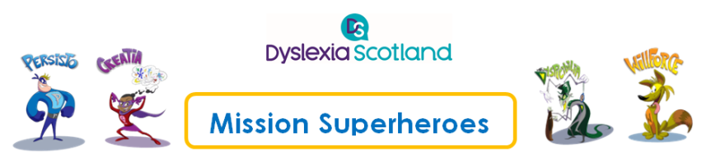

Session plan: Workshop Three: ‘Mission Superheroes’

(for P4-7 Pupils)

This is a flexible resource. Some suggestions for a one-hour pupil session are detailed in this plan.
The notes in this session plan are designed to accompany the pupil workshop presentation and the video for Workshop One (The Pupils’ workshop).

Overview
The ‘Dyslexia Characters’ provide an interactive journey for pupils. The ‘characters’ aim to help pupils to develop coping strategies to meet the four capacities of Curriculum for Excellence:
- Successful learners
- Confident individuals
- Responsible citizens
- Effective contributors.

Aims
To help pupils to:
- Understand what dyslexia is
- Develop their dyslexia superheroes (and a villain) to help them develop their own coping strategies and understand their strengths, difficulties and solutions
- Share what their dyslexia means to them or their friends – strengths, difficulties and what helps
- Find out where they can go for help

Outcome
At the end of the session, pupils will have their own interactive resources for use at home and the classroom.

Resources
- The professional learning guide, presentation and accompanying notes
- Wifi access for the films included within the presentation
- Digital projector, screen, computer and speakers
- Flipchart, flipchart paper, coloured pens and pencils

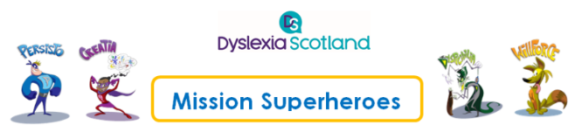

Hints and tips for teachers and teaching staff

- Teachers may need to demonstrate the drawing as Rossie did in the filmed workshop, or pupils may wish to volunteer to do this. The quality of the drawing is not important, but encouraging creative ideas is.

- Ask pupils to think of something they find hard in class that they’d like help with, such as Spiderman helping them to finish on time by shooting spiders’ webs to stop time.

- Encourage pupils to think of their strengths and remind them of the strengths the Superheroes all have.

- Emphasise that the difficulties they have are nothing to be ashamed of and that they should not be afraid to ask for help.

- Ask pupils to choose a superhero they like. Share examples of Dyslexia heroes to help pupils to come up with ideas e.g. :
- Book Girl
- Super Filer
- Helicopter Girl
- Focus Girl
- Dyslexalot
- Cosmos
- Red Line Man
- Captain Order
- Computer Girl
- Super Speller

A PDF download is available on the Toolkit http://addressingdyslexia.org/ambassador-outreach-programme

Format

For larger groups it is useful to subdivide into smaller groups for the sharing and drawing activities.

Session plan
The film available in the Guide shows one of the ‘Mission Superheroes' pupils’ workshops that took place during the second pilot phase of the Ambassador outreach programme, at Denny Primary School in April 2019.
The film is divided into sections, so that teachers can access the relevant part of the workshop. There is also a 12-minute interview with Rossie Stone talking about the programme, which teachers may wish to view as part of their preparation for the workshop.

Slides | Focus | Minutes
1- 2 | Introduction and background | 4
3 - 4 | Activity 1 – What is Dyslexia? Famous people quiz and dyslexia challenges | 10
5 - 7 | The Superheroes (Persisto, Willforce and Creatia | 7
8 | The Villain, Mr. Dyspicibilia | 2
9 | Activity 2 – The interaction. Pupils sharing their own experiences of dyslexia | 18
9 | Activity 3 – Your Mission (the drawing exercise). Pupils imagining solutions – how can the Superheroes help | 16
10 | Activity 4 - Review time. Pupils share their characters and explain what they can do. | 7
11 | Next steps. Highlight website for dyslexic children and young people, ‘Dyslexia Unwrapped’. Dyslexia Scotland welcomes drawings from dyslexic young people, so please share them for their website and magazine | 1
12 | Summary, close and thanks to everyone for participating. | 1
Total |  | I hour 6 minutes

Presentation Notes
Each slide has explanatory notes which explain the content of the slides and how to run the activities.

The film of the workshop (these film clips last for I hour 6 minutes in total)
- Introducing the workshop (3-4 minutes)
- What is Dyslexia? (10-11 minutes)
- The superheroes (8-9 minutes)
- The interaction: pupils sharing their own experiences of dyslexia (18 minutes)
- The exercise: imagining solutions – how can the superheroes help? (16-17 minutes)
- Review time! (6-7 minutes).

