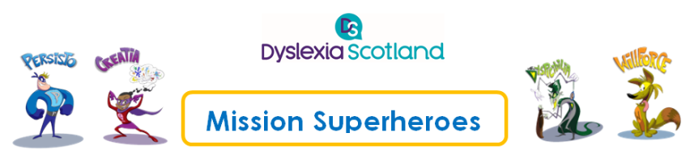

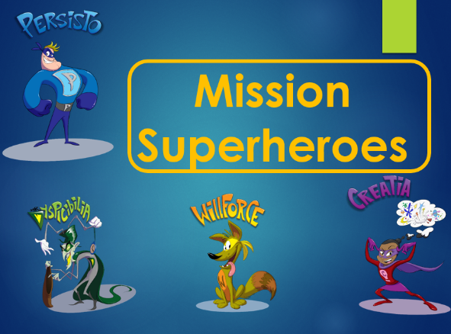

Presenter Notes - Ambassador Outreach Programme Workshop Presentation for Pupils

Slide Number | Notes
1 | Title slide to introduce the workshop. See ‘Introducing the workshop’ video, first 1-2 minutes.  This will be an exciting interactive workshop. The mission for the session is to help our Superheroes to fight against the Villain, Mr. Dyspicibilia.  It aims to help P4-7 pupils to learn more about dyslexia and ways of building on their strengths to discover how to overcome their dyslexia difficulties.  Background information (if required)  Paul McNeill and Rossie Stone are Dyslexia Scotland Ambassadors. They are both dyslexic and were the brains behind the Ambassador outreach programme, running 22 workshops in 4 local authorities during the two pilot phases, which were funded by the Scottish Government.  Paul is Head of Community Development for the Scottish Football Association and has delivered inspirational talks about his dyslexia at many events, including Dyslexia Scotland’s Education conference since he started as Ambassador in 2012. Paul came up with the idea for the workshops after doing many, many talks in schools, as he wanted to be able to share his messages about dyslexia in every local authority in Scotland through this programme. This Professional Learning Guide has been developed as a result of that work.  Rossie is the Founder of Dekko Comics. He discovered the power of comics as a learning tool and he now creates educational comics that are helping students across the UK. He created the comic characters that are used in the workshop for pupils.
2 | This slide was used during the film clip entitled ‘What is dyslexia?’  It can be presented as a quiz. Further information about Famous Dyslexic people can be found on Dyslexia Scotland’s ‘Famous People with Dyslexia’ leaflet  Ask the pupils if they know who these people are. Clues can be given if pupils do not recognise them. They are, from left to right:  - Sir Jackie Stewart (Dyslexia Scotland’s President and most famously known as he won Formula 1 3 times). Pupils may also be interested to know that a more recent racing car driver. Lewis Hamilton, is also dyslexic.  - Sir Richard Branson (Successful businessman and entrepreneur. Founder of Virgin Records which has expanded into many diverse sectors from travel to telecommunications, health, banking, music and leisure. There are now more than 60 Virgin companies worldwide, employing approximately 71,000 people in 35 countries)  - Maggie Aderin-Pocock (Space Scientist and presenter of ‘The Sky at Night’)  - Steven Naismith (another Dyslexia Scotland Ambassador – footballer, currently with Hearts, who has played for Rangers, Norwich, Everton, and Scotland football teams)  - Holly Willoughby (TV presenter)  - Keira Knightly (famous British actress)  The video shows Paul talking about each of the celebrities on the slide, which can be used as part of the quiz session.
3 | Dyslexia Scotland has a group of ‘Young Ambassadors’ from all over Scotland who do talks to raise awareness of dyslexia.
4 | This slide was used during the film clip entitled ‘What is dyslexia?’ (at 9 minutes into the clip)  These quotes are taken from interviews by Dyslexia Scotland with children and young people about their dyslexia. These can be replaced with other quotes.  Ask the class if they have had any struggles with dyslexia and give examples from the slide and from the pupils in the classroom. These are all challenges that dyslexic people may experience.  Ask the class to keep these challenges in mind as we will come back to these later in the workshop to look at how to overcome them.
5 | This slide was used during the film clip entitled ‘The Superheroes’  Explain that this exercise is about drawing superheroes to help with the challenges that we have just been talking about in the last slide. Demonstrate how important it is to ask for help - for example by trying to lift a table on your own and finding it impossible to do.  Introduce all the Superheroes one by one, using the slides (5-7) to show their characteristics.
6 | This slide was used during the film clip entitled ‘The Superheroes’  Introduce Willforce, the second Superhero – his qualities and what he finds hard himself.
7 | This slide was used during the film clip entitled ‘The Superheroes’ – the third of the three Superheroes is Creatia who is very good at thinking out of the box.  Paul gives an example of this in the video, about counting to ten and different ways of doing this.
8 | This slide was used during the film clip entitled ‘The Superheroes’ – we are now introducing the villain, ‘Mr Dyspicibilia’.  In the video Paul shows one way of getting around words that are difficult to pronounce, like this villain’s name – instead, he asks Rossie to introduce that character in this case.  Rossie explains that he, the creator of this character, deliberately made the name difficult, as it represents the challenges that a dyslexic person might find. The three heroes, or invisible forces we’ve just met, are the ones that represent all the strengths and the potential a dyslexic person has. Mr Dyspicibilia does the opposite. He is the voice whispering in your ear that you can’t do something. He highlights the negative aspects of dyslexia (or any other difficulties that a child or young person experiences). He has extra arms so he can do things like stealing your time, your confidence and taking your words away. The more you listen to him the stronger he becomes.  Mr. ‘D’ can be a hard villain to beat, but with the help of the three Superheroes – and the Superheroes the pupils are now going to create – it is possible.  Once all the comic book characters have been introduced, it is time to introduce the Mission you are going to set the pupils – to draw their own Superheroes.
9 | This slide was used during the film clip entitled ‘The Interaction’ and also for the film clip entitled ‘The exercise’.  Explain that during this part of the workshop we are now going to create our own Superheroes, using the power of our imagination. Using a flipchart to record the answers, ask pupils to say what their challenges are, e.g. reading off the board, distractions, remembering, time, reading and reading out loud. In the video, Rossie will draw a hero who has the powers to overcome all 6 of these difficulties, but he explains that he normally asks the pupils to create a character to overcome one of the challenges. It is up to the facilitator and the pupil how they’d like to do this.  Ask the pupils to share their ideas and either you or the pupils can draw these into a character.  For example, what can a character do to stop time? Give them a clock that reverses and freezes time – this also helps the pupil to remember something, as a question can be frozen or paused.  This part of the exercise is to demonstrate to the class how the characters can be developed. There is no need to worry about not being able to draw. Ask the whole class for ideas about how to depict the ideas as a drawing. Ideas for resources to help with drawing are in the Guide. Listen to the video for ideas of the solutions pupils suggested. Although this exercise is about the pupils developing and imagining characters with superpowers, there are some ideas (like the ones that are shared in the video) that may already exist. It is also a good way to find out what adjustments a pupils might find useful in the classroom. Encourage the class to choose a name for the character once created.  2. The next film clip, ‘The exercise’, will show how the presenters Paul and Rossie moved from the large group activity to working individually or in pairs or small groups. Hand out pens, pencils and paper and explain that pupils can now create their own comic book hero, or villain, to help them with their dyslexia. Remind them to think again of the challenges they came up with and how they’d like to overcome them. It may take a while for pupils to come up with ideas. Encourage any pupils who may need help in getting started and spend time listening to everyone’s ideas and checking in as they’re working on their drawings. Allow 15 minutes for the exercise and give pupils a few minutes’ warning before the end of the exercise.
10 | This slide was used during the film clip entitled ‘Review Time’.  Ask pupils to volunteer to come to the front of the class to explain who their Superheroes or Villains are and what they do to help their difficulties. They can do this on their own, in pairs or in small groups.  Allow 5 minutes to do this. If you wish to allow more time or another session with the pupils to share their characters, the workshop can be followed up at another time.  End the session by highlighting the Key messages on this slide.
11 | If any of your pupils wish to share their Superheroes or Villains, Dyslexia Scotland would love to hear from you, as we can add drawings or videos to Dyslexia Unwrapped, the website for children and young people with dyslexia. Send them to: info@dyslexiascotland.org.uk  For more information for parents and for teachers, visit Dyslexia Scotland’s website: www.dyslexiascotland.org.uk or, for teachers, the Addressing Dyslexia Toolkit: www.addressingdyslexia.org
12 | Last slide.

