“What to look for” Checklist – Curriculum for Excellence Early Level
This resource has been developed to support the Scottish Working Definition of Dyslexia.
The purpose of this resource is to guide initial gathering of evidence to support the collaborative process using the dyslexia identification pathway, but will not provide an identification of dyslexia. A copy of this tool should be kept in the learner’s records to inform appropriate future planning.
Learner’s Name |  | Nursery/School | Class | Practitioner Name and Role |  |  | Date

Health and Wellbeing - Strengths
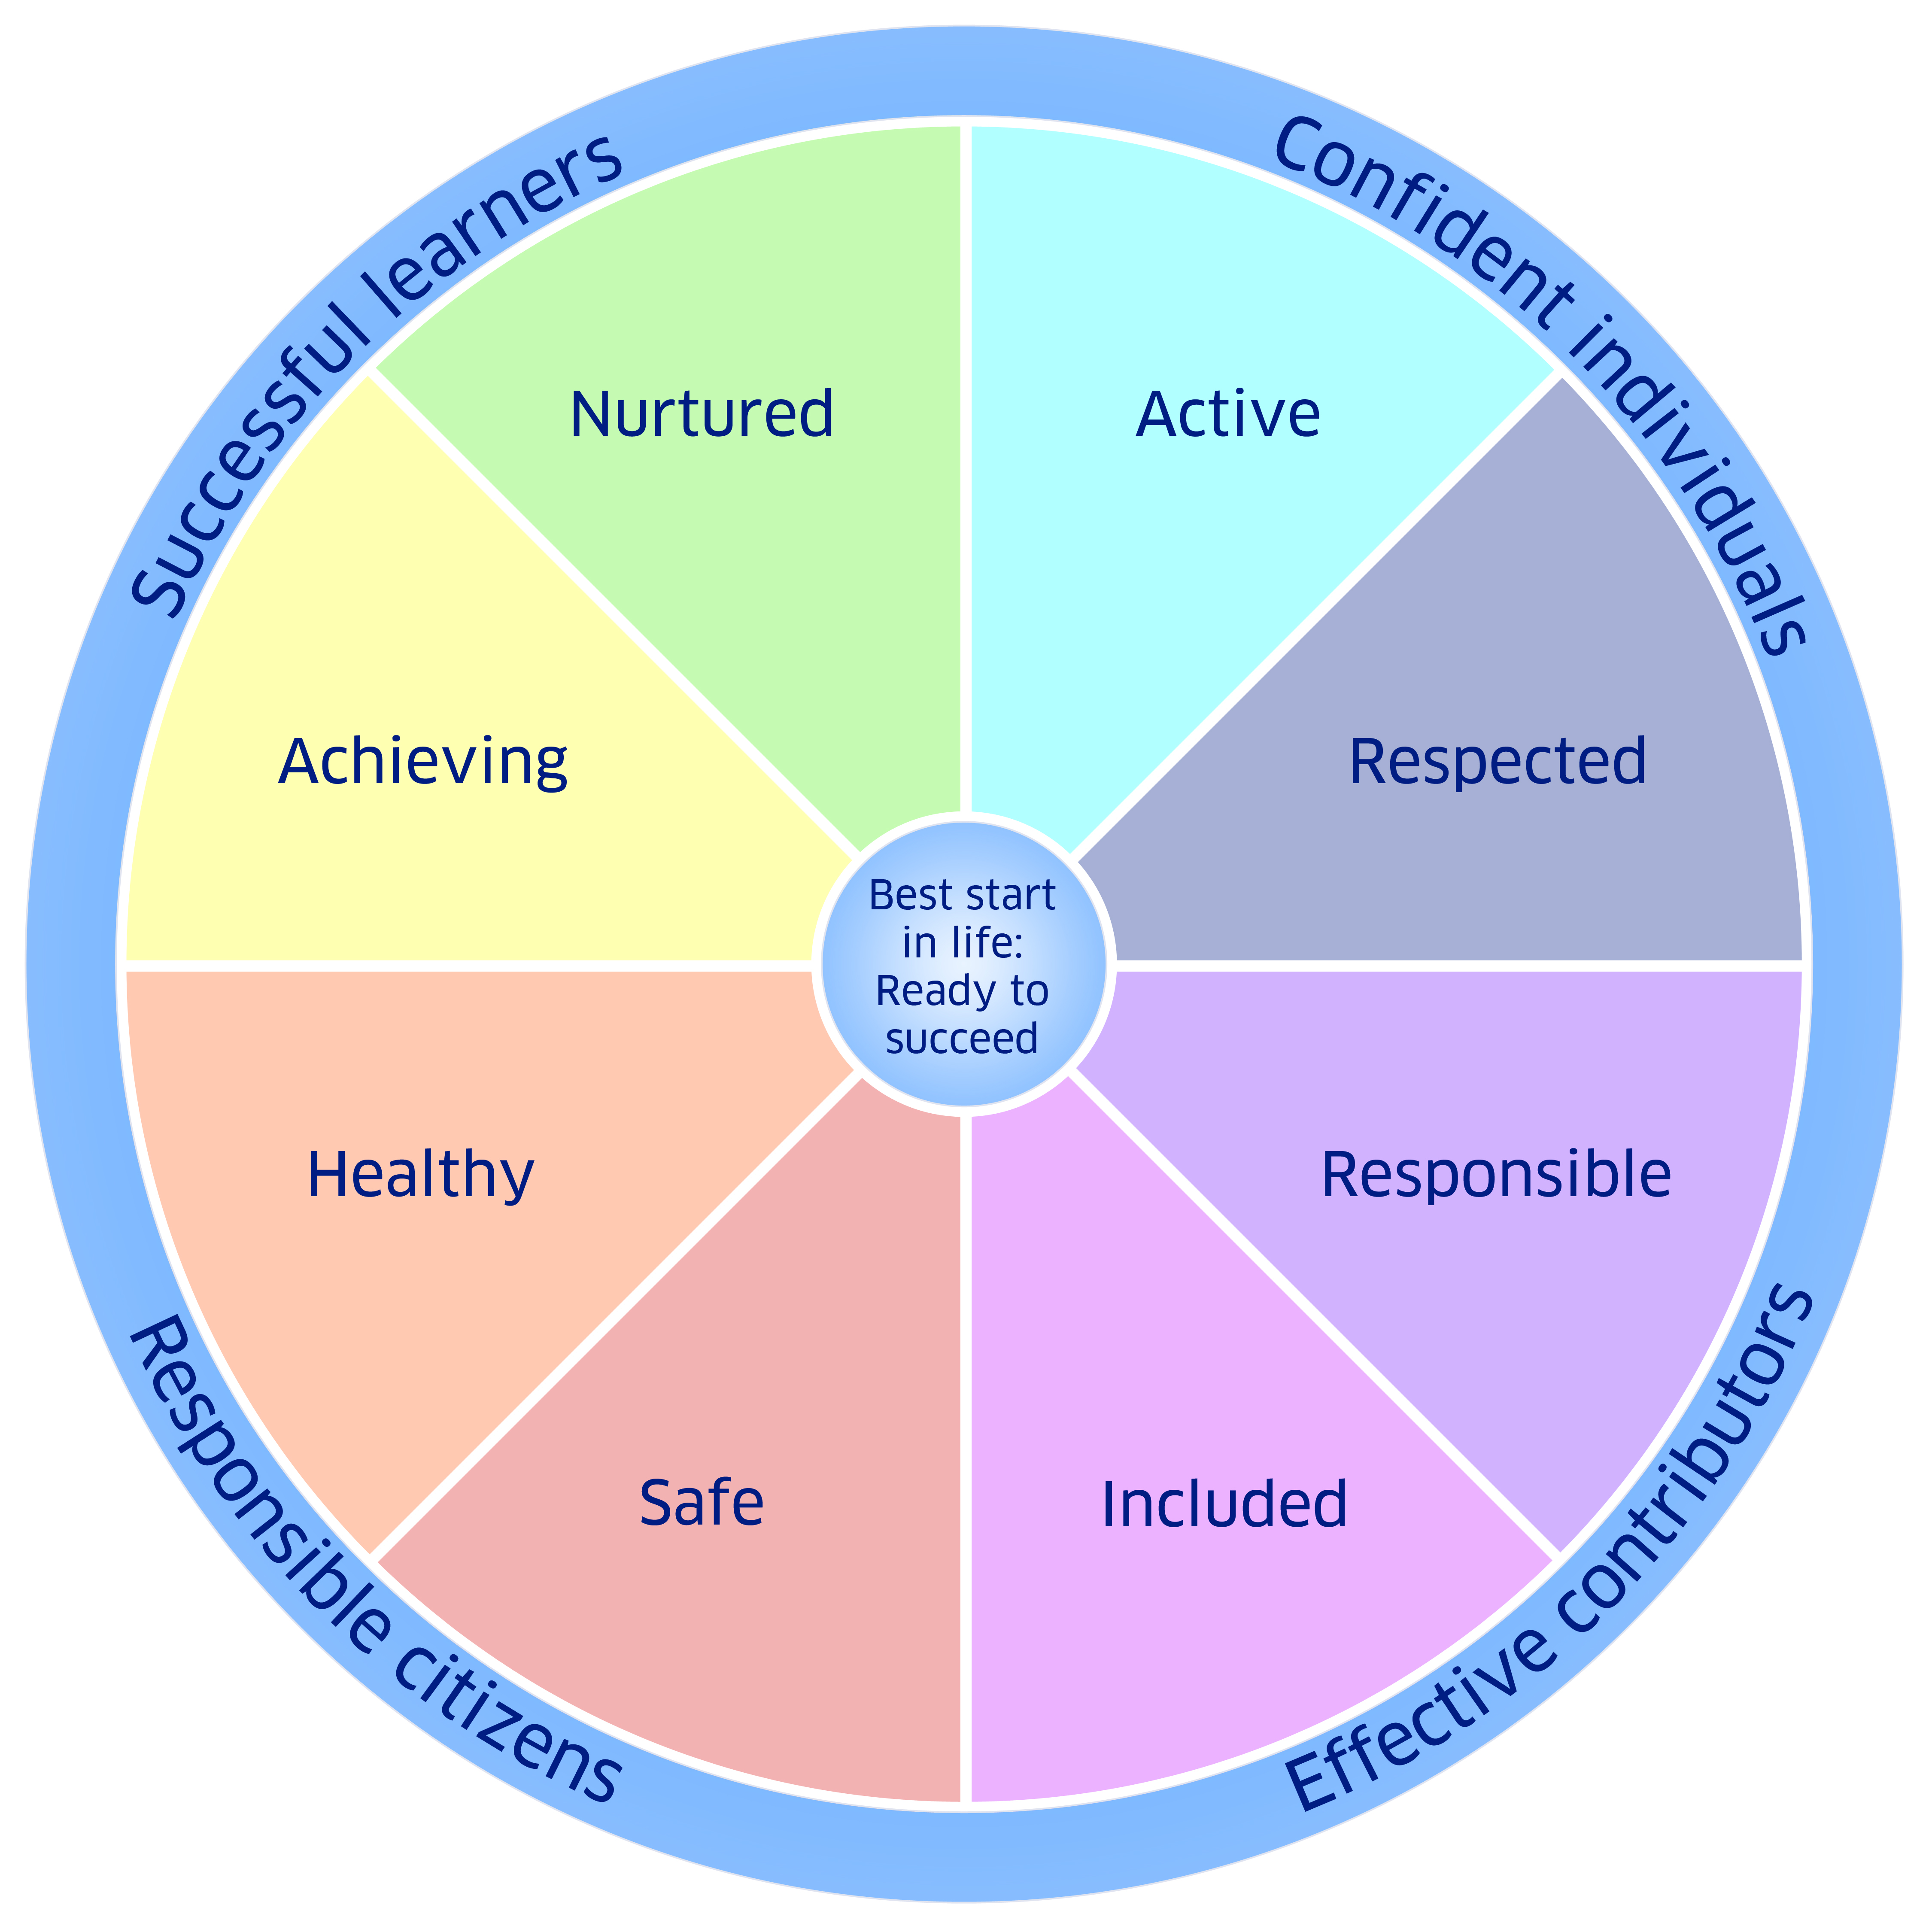 | It is important to include the strengths and motivations of the child which have been observed.  The use of the Wellbeing Wheel to gather strengths and areas of concern/difficulties can support the collation of a holistic profile through collaboration and discussion. However not all of the areas may be applicable.

Safe

Healthy

Achieving

Nurtured

Active

Respected

Responsible

Included

Other relevant factors to consider - these may include:

Information shared by parents/carers

Family history of dyslexia or difficulties with literacy

Other factors highlighted within the Toolkit - http://addressingdyslexia.org/other-factors-consider

Other relevant factors

Health and Wellbeing |  |  |  |  | Insert (copy & paste) Tick
Areas that may be affected which are not developmentally age and stage expected for example |  |  |  |  | Often | Sometimes |  | Rarely

Does not appear to want to engage in learning activities

Language development and expressive communication skills appears to be limited

Inconsistent profile – some days can be very good at activities and others less so

The Scottish Working Definition of Dyslexia . The following sections cover the associated difficulties in order. Not all areas may be applicable to each learner (age and stage appropriate).
Processing of language-based information (auditory and/or visual) |  |  |  |  | Insert (copy & paste) Tick
Areas that may be affected: |  |  |  |  | Often | Sometimes |  | Rarely
Appears to have difficulty processing verbal questions
Word finding difficulties are evident
Appears to have difficulties in following simple instructions
Appears to misunderstand information shared
Appears to have difficulty describing experiences and events
Difficulty in recognising the relationships between onset and rime – c/at and b/at; m/at and s/at
Confusion of similar sounding letters – d/t; f/v/th; short vowels
Consistent confusion of letters similar in shape: b/d,/p/q; u/n/m/w,
Inconsistent use of upper and lower case letters
Reversals of words – ‘was’ for ‘saw’, ‘god’ for ‘dog’
Difficulty in copying from the board or jotter
Phonological Awareness
Areas that may be affected: |  |  |  |  | Often | Sometimes |  | Rarely
Child finds it difficult to remember rhymes and understand rhyming link between words
Difficulty with listening to
Difficulty with keeping a simple rhythm e.g. clapping to the beat
Difficulty with identifying and or generating rhyme
Difficulty isolating words when listening to a sentence being spoken
Difficulty with recognising alliteration
Oral language skills and reading fluency
Areas that may be affected: |  |  |  |  | Often | Sometimes |  | Rarely
Oral language
Difficulty in communicating their message due to speech and language difficulties
Articulation may be poor
May often use the wrong word
Reading fluency
Difficulties with the acquisition of phonics
Severe difficulty in associating letters and sounds,
Omission or confusion over small words
Difficulties with the visual tracking of words and symbols
Does not appear to enjoy engaging with age appropriate books/text independently
Difficulties with the consolidation of previous words learnt
Short-term and working memory
Areas that may be affected: |  |  |  |  | Often | Sometimes |  | Rarely
Appears to forget information previously learnt
Confusion over using full stops and capital letters
Difficulty remembering a short sequence of numbers
Difficulties in remembering some everyday routines
Sequencing and directionality
Areas that may be affected: |  |  |  |  | Often | Sometimes |  | Rarely
May have difficulty following the sequence of a story
Difficulty retelling a story in a logical sequence
Expression of ideas, feelings and thoughts may be disorganised and poorly sequenced
Has difficulty in following the reading and writing direction of left to right and top to bottom
Number skills
Areas that may be affected: |  |  |  |  | Often | Sometimes |  | Rarely
Difficulty processing the concept of number bonds
Difficulty in processing the relationships between initial number bonds
Difficulties learning early number language and procedures e.g. multiple terms and subtraction and addition
Difficulty associating numbers and symbols
Difficulties with spatial awareness
Organisational ability
Areas that may be affected: |  |  |  |  | Often | Sometimes |  | Rarely
Remembering where things are in the nursery/classroom/home
Difficulty organising things needed for activities for which they are responsible
Difficulties in carrying out some everyday routines
Motor skills and co-ordination
Areas that may be affected: |  |  |  |  | Often | Sometimes |  | Rarely
Struggling to produce evidence of appropriate mark making, letter and number formation
Difficulty and/or extreme tenseness in holding pencil
Difficulties with scissor skills
Difficulties using the keyboard, tablet or mouse
Reluctance to participate in PE
Gross motor coordination difficulties e.g. starjumps, catching, throwing, balance
Additional Comments

