Addressing Dyslexia Toolkit - Professional Reflection and Planning Tool:  The Scottish Context  This professional reflection and planning tool support opportunities to reflect on your knowledge and understanding of the areas highlighted within the Addressing Dyslexia toolkit and help you plan the next steps in your professional learning. |  |  |  |  |  |  | 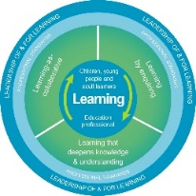
Name |  |  | Establishment |  |  | Date
Toolbox Focus area |  | My reflections on this section |  |  | My next steps and priorities for my professional learning.
The Scottish Context
Supporting Learners
Making Sense – dyslexia review and programme

Reflective Prompts | Next Steps and Priorities for my Professional Learning.
How does my understanding of dyslexia and inclusion impact on the learners I support?
How inclusive is my school community and how could we implement the Making Sense programme resources to support improvements?

