Parent/Carer Dyslexia Checklist

If you think your child or a child you are caring for may have dyslexia this checklist will be of help to the staff who are supporting them. Please answer as many questions as you can but remember that there are no right or wrong answers – each person is an individual, with different strengths. Think carefully, but not too long about your answers. Ask for help if you are not sure about how to answer any question - a member of the support staff at your school can help you.
Checklist for Dyslexia
Name of child/young person |  | Date of Birth
School |  | Class and year group
The views of the child/young person are very important, and it can be helpful to share and discuss these questions with them. They may also complete the ‘Learner Questionnaire’ either independently or with support.

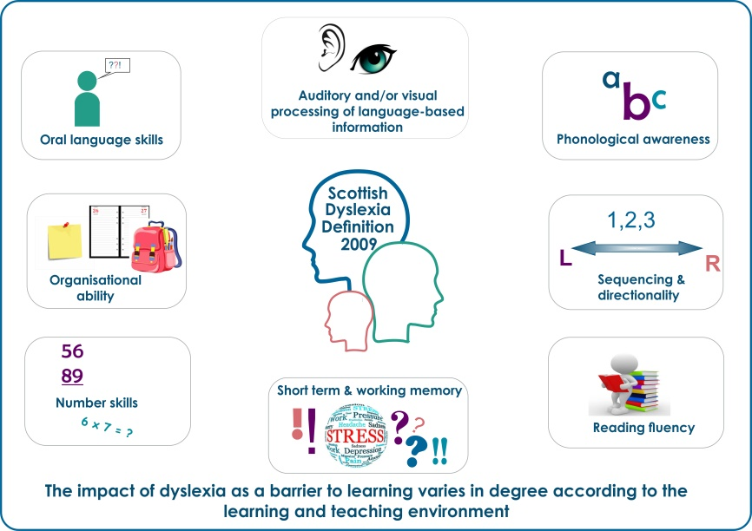

Scottish Working Definition of Dyslexia, 2009

Dyslexia can be described as a continuum of difficulties in learning to read, write and/or spell, which persist despite the provision of appropriate learning opportunities. These difficulties often do not reflect an individual's cognitive abilities and may not be typical of performance in other areas. The impact of dyslexia as a barrier to learning varies in degree according to the learning environment, as there are often associated difficulties such as:
- auditory and/or visual processing of language-based information
- phonological awareness
- oral language skills and reading fluency
- short-term and working memory
- sequencing and directionality
- number skills
- organisational ability
Motor skills and co-ordination may also be affected.

This form can be completed electronically; copy and paste the tick into the answer boxes.
Overview
 | Yes |  | No |  | ?
Does your child have good verbal skills, do they like to talk, share what they know and or tell stories?
Is your child always full of ideas about various things?
Do you think your child has a high sense of curiosity and wants to know about things?
What hobbies, skills or interests does your child have that we would not necessarily know about in school?
What aspect of school does your child enjoy most?

Background
Has the child/young person: | Yes |  | No |  | ?
a relative who is or thought to be dyslexic
experienced frequent ear infections in their early years
experienced several absences from school
moved schools several times
have you ever had concerns about your child’s speech development
had input from allied health professionals e.g. speech and language or occupational therapy
had a recent eye test to confirm their vison is satisfactory – with or without glasses

Reading
Does the child/young person: | Yes |  | No |  | ?
read for enjoyment
read very slowly
actively avoid reading
Prefer to listen to stories/audio books rather than read them
find reading difficult and tiring
Misread or misinterpret text or guess a story line or text
find it hard to say a word correctly (mispronounce)
have to read text over again to make sense
have difficulty finding information in a text
lose the place when reading
forget the beginning in longer questions
find it hard to use a dictionary or index

Writing
Does the child/young person: | Yes |  | No |  | ?
demonstrate a difference in what they can write down and what they can talk about
actively avoid writing
confuse words that are similar
appear to write slowly
have problems finding the exact word they want to use
miss out or add in letters of words
miss out little words
confuse or reverse letters in a word e.g. b/d; b/p; f/t; n/v
have messy or illegible handwriting
have difficulties with spelling

Numbers/Maths
Does the child/young person: | Yes |  | No |  | ?
mix up numbers or confuse maths symbols
confuse dates and times
have difficulty with directions (left/right)
find it hard to remember tables
find it hard to get information from graphs and charts
find mental maths very hard
get muddled when doing a complicated maths problem
have problems reading and understanding maths words
find it hard to remember the order of steps to solve problems

In general do you feel your child
 | Yes |  | No | ?
mispronounces words
jumbles up the order of sounds of words, for example ‘parcark’ instead of ‘carpark’
Appear to need more ‘thinking time’
Appear excessively tired when they get home from school
finds it difficult to understand what is expected of them whether that be homework, a class project to be completed at home or an assignment
struggles to start and/or get through homework, projects or assignments
finds it hard to finish work in time allowed
forgets or loses books and equipment
finds it hard to follow instructions
finds it hard to remember names of objects or people
finds it hard to remember messages
often puts things in the wrong order
has problems judging speed and distance
has poor balance, or appears clumsy
becomes easily distracted
miss deadlines, appointments etc.
tends to bump into things/people
appears/says they feel confused doing tasks that they find hard but feel other people find easier
tries to hide their difficulties from others
lacks self confidence
feels angry and frustrated at times
Is there anything you or your child would like to add?

Parent/Carer
I give permission for this information to be shared to support the collaborative assessment

Signature Date

Child/young person (If aged 12 and over)
I give permission for this information to be shared to support the collaborative assessment

Signature Date

There are many strengths associated with dyslexia and they are just as common as some of the difficulties experienced. People with dyslexia will find some things difficult but often will have other skills to help overcome these difficulties.

You may have ticked several ‘yes’ boxes – this does not necessarily mean that the child/young person is dyslexic. Many people experience some of these difficulties for a range of reasons e.g. stress, lots of school absences, eyesight or hearing difficulties or if English is not their first language.

Your responses will contribute towards a range of information which is considered when identifying dyslexia. It is important to remember that people with dyslexia have many strengths and further Information can be found at:

Dyslexia Scotland’s website - https://www.dyslexiascotland.org.uk/

Dyslexia Unwrapped a website designed for 8 – 18 years - https://unwrapped.dyslexiascotland.org.uk/

