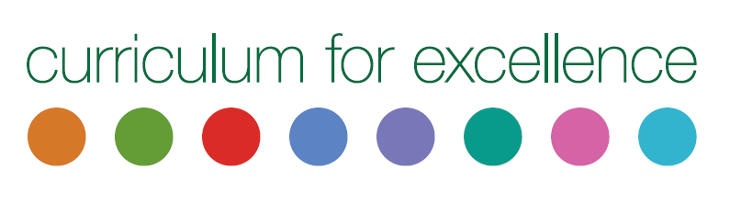
Collaborative Assessment Collation Form  Holistic overview for the identification of Dyslexia |  |  |  |  |  |  | Insert  School/  authority logo
Date |  |  | School
Pupil name |  |  |  |  | Date of birth
Year and Class |  |  |  |  | Chronological age
Positive strengths of pupil.

These assessments do not have to be ‘standardised’ formal/commercial assessments.
Assessment information is available on The Addressing Dyslexia Toolkit .
Area of assessment and information gathering |  | Comments – Provide a short summary of assessment results.
Pupil Dyslexia checklist
Pupil’s own thoughts on their experiences.
Observation -Information from class and home.
Reading

Evidence of reading levels and comprehension ability
Writing - Example of ‘Free writing’ to examine spelling, grammar, composition and handwriting.
Spelling - evidence of pupils spelling ability
Numeracy - times tables,
Number bonds, digit placement
Handwriting - Speed and legibility of writing.
Sequencing -Organisational skills
Motor skills - Spatial awareness, fine & gross motor control.
Sensory Perceptions
Other assessments
Suggested Approaches/Strategies.

