Insert School/authority logo | Form 3 - Collaborative Assessment Summary  Holistic overview for the identification of Dyslexia. www.AddressingDyslexiaToolkit.org  To be used with the Identification Pathway |  |  |  |  |  |  |  | 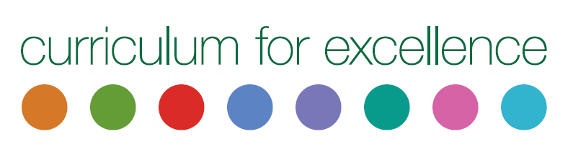
Date |  | School |  |  |  |  | Support notes - Referenced to the Scottish Working Definition of Dyslexia.  - Start with highlighting the learner’s strengths  - This is not a prescriptive list  - This document is only a summary overview and will support the development of a learner profile  - Evidence gathered for the assessment areas highlighted below does not have to be from standardised/formal/commercial assessments. The evidence can be gathered collaboratively through effective monitoring and assessment within Curriculum for Excellence  - Further assessment information is available on The Addressing Dyslexia Toolkit
Name |  |  |  |  | Date of birth
Year and Class |  |  |  |  | Chronological age
Positive strengths.

Information gathered and assessments - including associated difficulties |  |  | Comments – Provide a short summary of assessment results |  |  |  | Strengths identified in assessment areas | Areas for development | Suggested interventions and support – Including SQA Assessment Arrangements for course work and examinations
Learner Dyslexia Questionnaire
learner’s own thoughts on their experiences
Parental Questionnaire
Observation - information from class and home
Curricular assessments
Examples of class work
Standardised assessments
Processing of language-based information (auditory and/or visual)
Oral language skills and reading fluency
Phonological Awareness
Reading e.g. evidence of reading levels and comprehension ability , reading fluency and other areas highlighted in the PDF Reading Circle
Writing e.g. sample of free writing to examine spelling, grammar, composition, handwriting and other areas highlighted in the PDF Writing Circle
Short-term and working memory
Following instructions
Remembering and manipulating information
Sequencing and directionality
Awareness of left and right
Speed and legibility of writing
Motor skills and co-ordination
Fine & gross motor control
Organisational skills
Time management
Planning and organisation of tasks
Numeracy
Spatial awareness, sequencing, working memory,
times tables, number bonds, digit placement
Additional comments

